|  |  |
| --- | --- |
|  |  |
| **When:** | *10 FEBRUARY 2017 - 14h00 to 15h00* |
|  |  |
| **Venue:** | ***GoToMeeting*** |
|  |  |

**1st meeting of the CENELEC/BTWG 154-1**

|  |  |  |
| --- | --- | --- |
| **1** | **Approval of the agenda** |  |

The on-line meeting was opend by the convenor, Mr K. Behnisch , who briefly introduced the background and goal of this BT Working Gropup.

|  |  |  |
| --- | --- | --- |
| **2** | **Roll call** | BTWG_154-1_SEC_01004 |

See attached document for the participants list.

|  |  |  |
| --- | --- | --- |
| **3** | **Scope and Terms of Reference** | BTWG154-1 / Sec / 01001 / DC |

Scope and terms of Reference where agreed and laid down in following documents:

* BTWG_154-1_SEC_01001a_draft_scope_ToR_agreed meeting_clean
* BTWG_154-1_SEC_01001a_draft_scope_ToR_agreed meeting_TC

These have been made available on collaboration tool as versions of doc. 01001 and will be submitted to CLC/BT for approval with this report.

|  |  |  |
| --- | --- | --- |
| **4** | **document 'CISPR work fulffiling essential requirements of EMC Directive 2014/53'** draft proposal as starting point+ | BTWG154-1 / Sec / 01002 / DS |

Rather than purely focussing on document 01002, the convenor started a mind-map inventorying the different aspects of the issue surrounding the use of statistical rules. This mindmap is attached in Annex 1 to this report.

With the aim to produce a document ‘Providing sound justification at both managerial and technical level to the EC services and MS in order to clear the issues’ [with regards to ‘EMC statistical rules’ in EMC standards in relation to the EMCD (2014/30/EU)], the participants agreed to proceed as follows:

* Based on the mind map, a project of table of contents to be put forward.
* This empty framework document to be made available on Collaboration Tool for participants to provide inputs in the different chapters (to be consolidated by CCMC)

This document will be referenced as document **BTWG_154-1_SEC_00002**

**Note:**

*While welcoming classic inputs on the document; the Convenor and Secretary offer an alternative (and experimental) way of collaborative authoring by the use of ‘VDE Smashdocs’. Participants to the BTWG that wish to contribute in this way are invited to liaise with the BTWG Secretariat in order to get a registered access. We hope to get some useful feedback on collaborative authoring, independent of the technology platform, for the time being kindly provided by DKE/VDE.*

Target date: report to 155th CLC/BT meeting (2017-05-31)

|  |  |  |
| --- | --- | --- |
| **5** | **AoB and next meetings** |  |

~~Secretary to launch a doodle as for mid-april 2017.~~

**Next meeting: 2017-04-07 from 14:00 to 16:00**

**Information note**

Documents are numbered xxyyy where:

* XX = 00 is used for general documents like ToR or deliverables
* XX = ## is used for the number of the meeting
* YYY is an incremental counter

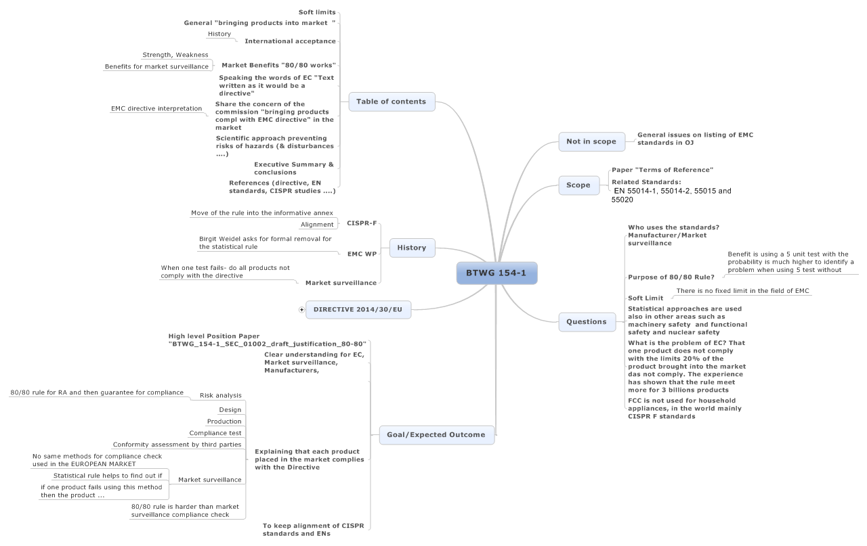**Annex 1 – Mindmap**