**Final Draft, December 2017**

**Guide for the EMCD (Directive 2014/30/EU)**

**Table of contents**

1 SCOPE 6

1.1 General 6

1.2 Geographic Application 9

1.2.1 Application in non-EU States, countries & territories 9

1.2.2 Mutual Recognition Agreements (MRAs) 9

1.2.3 Agreements on Conformity Assessment and Acceptance (ACAAs) 10

1.3 Placing on the market/putting into service 10

1.3.1 Placing on the market 10

1.3.2 Putting into service 11

1.3.3 For the special case concerning fixed installations, see Section 1.6 of this Guide. Special measures regarding equipment at trade fairs, etc 11

1.4 Equipment and products 12

1.4.1 Equipment without electrical and/or electronic parts 12

1.4.2 Explicit exclusions from the EMCD 12

1.4.4 Inherently benign equipment 15

1.4.5 Custom built evaluation kits 17

1.4.6 Classification as apparatus or fixed installation 18

1.5 Defining the scope of apparatus 19

1.5.1 Finished appliances 20

1.5.2 Several products 20

1.5.3 Components/Sub-assemblies 20

1.5.4 Mobile installations 22

1.6 Defining the scope for fixed installations 22

1.6.1 Fixed installations 22

1.6.2 Specific apparatus for fixed installations 23

1.7 Specific Case: Jammers 23

2 Essential requirements 23

3 obligations of economic operators 24

4 CONFORMITY ASSESSMENT Procedure for apparatus 24

4.1 Introduction 24

4.2 Risk analyses and risk assessment 27

4.3 EMC Assessment 27

4.3.1 General Concept 27

4.3.2 Use of EMC harmonised standards 29

4.3.3 An EMC assessment where no harmonised standards have been applied 32

4.4 Documentation required by the EMCD 34

4.4.1 Technical documentation 34

4.4.2 EU Declaration of Conformity 35

4.5 CE Marking and information 37

4.5.1 CE marking 37

4.5.2 Other identifying marks 37

4.5.3 Information for traceability 38

4.5.4 Information concerning the use of apparatus 38

4.5.5 Information when compliance is not ensured with essential requirements in residential areas 39

5 Fixed Installations 40

5.1 Essential Requirements 40

5.2 Documentation 42

5.3 Responsible person for fixed installations 42

5.4 Requirements for specific apparatus for given fixed installations 42

5.4.1. Obligations when the exemption clause is used for specific apparatus 43

6 Market surveillance of the EMCD 44

7 Notified Bodies 44

7.1 Introduction 44

7.2 Subcontracting 46

7.3 Information exchange 47

7.4 Coordination between Notified Bodies 47

7.5 Complaints regarding the service provided by NB 47

ANNEX 1 - Overall flowchart 48

ANNEX 2 - Guidance on using a harmonised standard 49

ANNEX 3 - EMC assessment where harmonised standards do not exist or are not fully (applied) 51

ANNEX 4 - Application of Directives 2014/53/EU, 2014/35/EU and 2014/30/EU 57

ANNEX 5 - Acronyms and abbreviations 59

**ANNEX 6 - Organisations and Committees** 63

**Table of Flowcharts**

Flowchart 1 – Scope 8

***Disclaimer***

*These guidelines are intended to be a manual for all parties directly or indirectly affected by the “new” Electromagnetic Compatibility Directive 2014/30/EU (EMCD). They assist in the interpretation of the Directive but do not substitute for it; they explain and clarify some of the most important aspects related to its application. The Guide is also intended to ensure the free movement of products in the EU Internal Market by agreement of these explanations and clarifications, reached by consensus amongst Member States and other stakeholders.*

*This Guide will be reviewed periodically to be kept up to date.*

*This Guide is publicly available but is not binding in the sense of a legal act adopted by any of the EU institutions, even if the word 'shall' is used in many parts of this Guide. In the event of any inconsistency between the provisions of the EMCD and this Guide, the provisions of the EMCD prevail.*

*The European Commission undertakes to maintain this Guide to ensure that the information is accurate and up to date. Errors brought to the Commission’s attention, will be corrected. However, the Commission accepts no responsibility or liability whatsoever with regard to the information in this Guide. The information:*

* *is of a general nature only and is not intended to address the specific circumstances of any particular individual or entity;*
* *is not necessarily comprehensive, complete, accurate or up-to-date;*
* *sometimes refers to external information over which the Commission has no control and for which the Commission assumes no responsibility;*
* *does not constitute legal advice.*

*Finally, attention is drawn to the fact that all references to the CE marking and EU Declaration of Conformity relate to the EMCD only. A product only benefits from the free circulation in the Union market if the product complies with the provisions of all the applicable Union legislation. Reference is therefore made, whenever necessary but not always, to other EU legal acts.*

Introduction

This Guide should always be read in conjunction with the 'Blue Guide' on the implementation of EU product rules[1].

The purpose of this Guide is to give guidance on certain matters and procedures of the EMCD.

The new EMCD (Directive 2014/30/EU) repeals and replaces the old EMCD (Directive 2004/108/EC). It maintains the same objectives - to guarantee the free movement of equipment[2] and to create an acceptable electromagnetic environment in the Union territory[3].

The main objective of the EMCD is thus to regulate the electromagnetic compatibility of equipment. In order to achieve this objective, provisions have been put in place so that:

* equipment shall comply with the requirements of the EMCD when it is made available on the market and/or put into service when properly installed, maintained and used for its intended purpose;
* the application of good engineering practice is required for fixed installations, with the possibility for the competent authorities of Member States to request evidence of compliance of the fixed installation, and, when appropriate, initiate an evaluation if non-compliances are established.

After 2010, the Blue Guide was updated to the NLF. The NLF is a flexible regulatory framework for the marketing of products. In 2014 a set of Directives (including the new EMCD and the new LVD) were aligned according to the NLF. Also in 2014, the Radio Equipment Directive (RED) entered into force and is applicable as of 13 June 2016, subject to one year transitional period (ended on 12 June 2017).

The EMCD is applicable as of 20 April 2016 on.

The main changes in the new EMCD (Directive 2014/30/EU), as compared to the old EMCD (Directive 2004/108/EC), relate with the alignment with the new legislative framework, Standardisation Regulation (EU) No 1025/2012 and Article 291 of the TFEU (Implementing Acts).

The essential requirements have not been modified and therefore the substance of the harmonised standards for apparatus is not affected due to the new EMCD.

The scope remains mainly the same, compared to the old EMCD. The new EMCD includes only a new exception on Custom built evaluation kits (see section 1.4.5).

However, the scope of the EMCD has been indirectly affected and modified due to the new RED, which has repealed and replaced the R&TTED[4]. The new RED, compared to the R&TTED, has introduced some modifications (for more details, see section 1.4.2.1 and Annex 4 of this Guide). As a result, equipment that was covered by the R&TTED, but is not covered by the RED, is not excluded anymore from the EMCD and equipment which was not covered by the R&TTED, but it is covered by the RED, is now excluded from the EMCD.

This Guide has been structured in a logical way suitable for users who need to ensure that their equipment complies with the EMCD. It is divided into the following Chapters:

1. **Scope**: allows economic operators to quickly decide whether their equipment falls under the scope of the EMCD and if so, if it is apparatus or a fixed installation.
2. **Essential requirements**.
3. **Obligations of economic operators**
4. **Conformity assessment procedure for apparatus:** gives information including: the steps of an EMC assessment; information and documentation requirements; EU Declaration of Conformity and CE marking. More detailed guidance is provided for an EMC assessment where harmonised standards are not used or do not cover all essential requirements.
5. **Procedures for fixed installations**: on the relevant requirements and documentation needed for fixed installations, including the use of apparatus specifically for incorporation into a particular fixed installation.
6. **Market surveillance**: relates to the duties of the national authorities ensuring only compliant apparatus circulates in the Union.
7. **Notified Bodies**: their role, selection, coordination and the treatment of complaints.

# SCOPE

## General

The EMCD applies to a vast range of equipment encompassing electrical and electronic appliances, systems and installations.

The main objective of the EMCD is to guarantee the free movement of equipment and to create an acceptable electromagnetic environment whilst ensuring that equipment will function as intended in that environment. In order to achieve it, a harmonised and acceptable level of protection is requested in the Directive, based on Article 114 of the TFEU, leading to full harmonisation in the Union.

The level of protection requested is further specified in the EMCD by protection aims in the field of electromagnetic compatibility as defined in Annex I of the EMCD.

Obviously, the goal of the essential requirements is not to guarantee absolute protection of equipment (e.g. zero emission level or total immunity). These requirements accommodate both physical facts and practical reasons. To ensure that this process remains open to future technical developments, the EMCD only describes the essential requirements along general lines.

Essential requirements include both general requirements for equipment as well as specific requirements for fixed installations.

When compliant with the provisions of the EMCD, equipment may be made available on the market and/or put into service in the Union territory and operated as designed and intended in the expected electromagnetic environment.

The EMCD does not regulate the safety of equipment in respect of people, domestic animals or property[5]. According to Article 1, the EMCD covers exclusively the electromagnetic compatibility of equipment. However, it should be noted that other directives may require higher requirements for EMC phenomena in order to satisfy their specific safety provisions.

**The EMCD is therefore not a safety related Directive.**

Functional safety aspects based on electromagnetic disturbances are regulated for instance by the Machinery Directive 2006/42/EC, the Low Voltage Directive 2014/35/EU and the General Product Safety Directive 2001/95/EC.

In order that the reader may easily decide whether an equipment falls under the scope of the Directive, and the procedures that are to be applied, a series or decision flow-charts have been incorporated into the Guide. Flowchart 1 deals with the first step in this process.

**no**

**yes**

**yes**

**A**

**Contains electrical/**

**electronic par**

**ts**

**no**

**yes**

**Product families excluded**

**from EMCD by explicit**

**mention**

**Inherently benign**

**equipment**

**no**

**To flow**

**-**

**chart 2**

**no**

**Start**

**no**

**yes**

**yes**

**yes (*)**

**A**

**Contains electrical/**

**electronic parts**

**no**

**yes**

**Covered by other**

**specific Directives**

**Co**

**vered by other**

**specific Directives**

**Product excluded**

**Inherently benign**

**equipment**

**no**

**To flow**

**-**

**chart 2**

**no**

**Start**

(*)EMC Directive ceases to

apply for requirements laid

down more specifically by

other Direct

ives

**Excluded from the EMC Directive**

Flowchart 1 – Scope

## Geographic Application

### Application in non-EU States, countries & territories

The geographical application is described in Chapter 2.8 "geographical application" of the Blue Guide. The EMCD also applies in the EEA-EFTA States (Liechtenstein, Iceland, and Norway) and Turkey.  Therefore, when the terms “European Union”, “Union”, “territory” or 'Member States' are used in this Guide, they apply to the EEA-EFTA States (Liechtenstein, Iceland, and Norway) and  Turkey.

### Mutual Recognition Agreements (MRAs)

MRAs are agreements established between the Union and the third countries for the purpose of mutual recognition of conformity assessment of regulated products.  It is noted that it depends on the scope of each MRA, before deciding if it relates with the EMCD..

Specific information on MRAs may be found in Chapter 9.2 (Mutual Recognition Agreements - MRA) of the Blue Guide and the relevant Commission’s website[6].

MRA with Switzerland

The MRA concluded with Switzerland, which entered into force on 1 June 2002,[7] is a comprehensive agreement. Annex 1, Chapter 9, of the Agreement as amended by Decision No 1/2017 of the Committee established under the Agreement contains adaptations on the EMCD. In addition, the relevant Swiss legislation is adapted to the EMCD.

The EMCD and this Guide shall be read in conjunction with the adaptations in the MRA. The most important adaptations which relate with the obligations of the economic operators are the following:

(a) for the purpose of the obligations in Article 7(6) and 9(3) of the EMCD and the corresponding Swiss provisions, it shall be sufficient to indicate the name, registered trade name or registered trade mark and the postal address at which the manufacturer established within the territory of either the European Union or Switzerland can be contacted. In cases where the manufacturer is not established within the territory of either the European Union or Switzerland, it shall be sufficient to indicate the name, registered trade name or registered trade mark and the postal address at which the importer established within the territory of either the European Union or Switzerland can be contacted;

(b) for the purpose of the obligations in Article 7(3) and 9(7) of the EMCD and the corresponding Swiss provisions, it shall be sufficient that the manufacturer established within the territory of either the European Union or Switzerland keep the technical documentation and the EU declaration of conformity for 10 years after the equipment has been placed on the market in either the European Union or Switzerland. In case the manufacturer is not established within the territory of either the European Union or Switzerland, it shall be sufficient that the importer established within the territory of either the European Union or Switzerland keep a copy of the EU declaration of conformity at the disposal of the market surveillance authorities and ensure that the technical documentation can be made available to those authorities upon request for 10 years after the equipment has been placed on the market in either the European Union or Switzerland;

(c) for the purpose of the obligation in Article 8(2) of the EMCD and the corresponding Swiss provisions, authorised representative shall mean any natural or legal person established within the European Union or Switzerland who has received a written mandate from a manufacturer to act on his behalf pursuant to Article 8 (1) of the EMCD or the corresponding Swiss provisions.

### Agreements on Conformity Assessment and Acceptance (ACAAs)

Agreements on Conformity Assessment and acceptance of industrial products are intended to be established between the Union and the government of EU Neighbouring countries (for more details see Chapter 9.1 "Agreements on Conformity Assessment and Acceptance" of the Blue Guide).

## Placing on the market/putting into service

### Placing on the market

The EMCD applies to equipment placed on the market and then to any subsequent operation which constitutes making available until it reaches the end-user.

A product is placed on the market when it is made available for the first time on the Union market. Placing on the market refers to each individual product, not to a type of product, and whether it was manufactured as an individual unit or in series.

Equipment shall comply with the legal requirements that were in place at the time of its placing on the market.

When equipment is constructed for own use or bought by a consumer in a third country while physically present in that country and brought by the consumer into the EU for the personal use of that person, it is not considered to be placed on the market.

For details on the placing on the market and making available on the market, see Chapters 2.1, 2.2 and 2.3 of the Blue Guide.

### Putting into service

Articles 4 and 5 of the Directive refer also to putting into service.

However the provisions relating to the obligations of the economic operators (Chapter 2 of the EMCD) refer only to equipment placed on the market and made available on the market.

Therefore, Member States shall allow the putting into service and use of equipment if it complies with the EMCD and shall not allow equipment which was placed on the market, to be put into service, if it is not compliant with the EMCD.

On the other hand, equipment can be prohibited if it falls also within the scope of another legislation - regulating other aspects (other than EMC aspects) - and that equipment is not compliant with that other legislation.

### Special measures regarding equipment at trade fairs, etc

According to Chapter 2.3 "Placing on the market" of the Blue Guide, placing on the market is considered not to take place where a product is displayed or operated under controlled conditions at trade fairs, exhibitions or demonstrations.

Article 5.3 of the Directive contains the following details on the conditions applicable at trade fairs, exhibitions or demonstrations:

1. a visible sign clearly indicates that such equipment may not be made available on the market and/or put into service until it has been brought into conformity with this Directive; and
2. demonstration may only take place provided that adequate measures have been taken to avoid electromagnetic disturbances.

## Equipment and products

### Equipment without electrical and/or electronic parts

Equipment which does not contain electrical and/or electronic parts will not generate electromagnetic disturbances and its normal operation is not affected by such disturbances. Hence, equipment without electrical and/or electronic parts is not in the scope of the EMCD.

### Explicit exclusions from the EMCD

The EMCD excludes the following types of equipment:

#### Radio equipment

According to Article 2(2)(a) of the EMCD, equipment within the scope of the R&TTED is excluded from the EMCD. As of 13 June 2017, the R&TTED has been replaced by the RED[8]. Under Article 50 of the RED, references to the R&TTED shall be construed as references to the RED. Therefore the exclusion in Article 2(2)(a) of the EMCD shall be construed as any equipment falling within the scope of the RED. The RED covers most radio equipment and include EMC essential requirements identical to those of the EMCD. This means that the essential requirements in the EMCD are obligatory for that radio equipment. However, radio equipment falling under the scope of R&TTED and now the RED does not fall under the scope of EMCD (Article 2.2.a). Consequently, reference to the EMCD shall not be made in the EU Declaration of Conformity of a radio product under the R&TTED and now the RED.

The RED, compared to the R&TTED, applies to:

- pure radio sound and radio TV receive-only equipment;

-equipment operating below 9 kHz;

Radio-determination equipment is now clearly included within the scope of the RED.

The RED, compared to the R&TTED, does not apply to pure wired telecom terminal equipment.

For further detailed explanation, see Annex 4 and any guidance on RED published on the website of the European Commission.

#### Aeronautical products

According to Article 2.2.b, Aeronautical products, parts and appliances as referred to in Regulation (EC) No 216/2008[9] (as amended) are excluded from the EMCD.

#### Radio equipment intended for use by radio amateurs

The EMCD excludes (Article 2.2.c) radio equipment used by radio amateurs within the meaning of the Radio Regulations adopted in the framework of the Constitution of the International Telecommunication Union and the Convention of the International Telecommunication Union (unless if the equipment is made available on the market).

In any case if radio equipment, as defined in the RED,[10] is made available on the market (including cases where the intended use is for radio amateurs) then it is covered by the RED (see Annex I of the RED).[11]

* + 1. *Equipment covered by other specific Union legislation*

According to Article 2(3) of the EMCD, if the EMC requirements for equipment are wholly or partly laid down more specifically by other Union legislation, the EMCD shall not apply, or shall cease to apply, to that equipment in respect of such requirements from the date of implementation of that Union legislation.

The following list contains examples of equipment **excluded for both emission and immunity purposes** from the EMCD:

* Motor vehicles equipment: Regulation (EC) 661/2009, as amended, (UNECE Regulation 10).

Hence the following are totally excluded from the scope of the EMCD:

1. Vehicle and equipment subject to type approval under UNECE Regulation 10;
2. Equipment brought to the market as spare parts which is obviously identified as a spare part by an identification number and is identical and from the same manufacturer as the corresponding original equipment manufacturer (OEM) part for an already type-approved vehicle (see Paragraph 3.2.8 of UNECE Regulation 10);
3. Equipment sold as aftermarket equipment, if within the scope of UNECE Regulation (see diagram in Paragraph 3.2.1 of UNECE Regulation 10) and if it is related to 'immunity related functions' as defined in UNECE Regulation 10;

It is noted that equipment, sold as aftermarket equipment, intended for the installation in motor vehicles and is not related to immunity related functions (see paragraphs 2.12 and 3.2.9 of UNECE Regulation 10), needs a DoC under the EMCD; this DoC shall refer to the EMCD as well as to the provisions stipulated in Paragraph 3.2.9 of UNECE Regulation 10.

-Active implantable Medical Devices: Covered by Directive 90/385/EEC [12];

* Medical Devices: Covered by Directive 93/42/EEC[13];
* In vitro Diagnostic Medical Devices: Covered by Directive 98/79/EC[14];
* Marine equipment: Covered by Directive 2014/90/EU[15];
* Agricultural and forestry tractors covered by Regulation (EU) No 167/2013[16];
* Two or three-wheel motor vehicles within scope of Regulation 168/2013[17];

The following are examples of equipment **excluded for immunity purposes only** from the EMCD:

* Measuring instruments; Covered by Directive 2014/32/EU[18]
* Non-automatic weighing instruments: Covered by Directive 2014/31/EU [19].

### Inherently benign equipment

Equipment which is inherently benign in terms of electromagnetic compatibility is excluded from the scope of the EMCD[20].

Equipment is considered inherently benign in terms of electromagnetic compatibility if its inherent physical characteristics are such that:

1. it is incapable of generating or contributing to electromagnetic emissions which exceed a level allowing radio and telecommunications equipment and other equipment to operate as intended; and
2. it will operate without unacceptable degradation in the presence of the electromagnetic disturbance normally present in its intended environment.

Both conditions need to be met in order to classify equipment as inherently benign.

The application of the above enables the exclusion of the following products (not exclusive) from the application of the EMCD, provided that they include no active electronic part(s):

* Cables and cabling[21], cables accessories, considered separately;
* Equipment containing only resistive loads without any automatic switching device; e.g. simple domestic heaters with no controls, thermostat, or fan;
* Batteries and accumulators (without active electronic circuits);
* Corded headphones, loudspeakers without amplification, guitar inductive sensors without active electronic parts;
* Pocket lamps (including those containing LEDs) without active electronic circuits;
* Induction motors without electronic circuits;
* Quartz watches (without additional functions, e.g. radio receivers);
* Home and building switches which do not contain any active electronic components;
* Passive antennas;
* Electromagnetic relays without active electronic parts;
* Electromagnetic locks without active electronic parts;
* Cathode ray tubes;
* Protection equipment which only produces transitory disturbances of short durationduring the clearing of a short-circuit fault or an abnormal situation in a circuit and which do not include active electronic components, such as fuses and circuit breakers without active electronic parts or active components;
* High voltage types of equipment in which possible sources of disturbances are due only to localised insulation stresses which may be the result of the ageing process and are under the control of other technical measures included in non-EMC product standards, and which do not include active electronic components.

Illustrative examples:

* High voltage inductors;
* High voltage transformers.

If the product under assessment is not included in the list of examples above and the EMC assessment establishes that the apparatus concerned is inherently benign in terms of electromagnetic compatibility (both for emission and immunity) according to Article 2.2.d, the EMCD shall not apply. However, it is recommended to document the results of the assessment and its conclusion.

### Custom built evaluation kits

EMCD introduces an exemption for the custom built evaluation kits destined for professionals to be used solely at research and development facilities for such purposes (Article 2.2.e of the EMCD).

The exemption includes several elements and only if the products fulfil all the elements they can be exempted, on the basis of Article 2.2.e of the EMCD, from the scope of the EMCD:

* **Custom-built**

1. A kit that has been built on the basis of a specific request from a specific customer or from a group of customers involved in a joint research and development project as for all or certain characteristics of the evaluation kit

OR

1. A kit that has been built for the specific requirements of a specific customer or a group of customers involved in a joint research and development project as for all or certain characteristics of the evaluation kit.

The unique design and characteristics of the kit makes it solely suitable for that research and development project.

If that evaluation kit is later on provided on a regular basis or once the kit is not used for that joint research and development project purpose, it can no longer be considered a custom-built evaluation kit.

* **Evaluation kits**

A printed circuit board with an integrated circuit and support components to produce a working circuit for evaluation and development.

* **Destined for professionals (customers), to be used solely at research and development facilities**

Research and development facilities meaning public or private research and development bodies.

* **For research and development purposes**

Evaluation kits to be used in testing for further development/ improvement of the function of the equipment under research and development.

**Non-exhaustive list of examples of evaluation kits that do not benefit from this exemption (even if there is a possibility for the user to adapt it to his specific needs or to build it himself):**

* All devices/equipment used on a regular basis (such as laboratory equipment) to perform tests for the purposes of research and development or for other applications such as to demonstrate the conformity or quality of a product.
* Evaluation equipment for users in general in R&D departments (in this case, the equipment is always the same and is not "custom built").

### Classification as apparatus or fixed installation

The EMCD defines equipment as any apparatus or fixed installation. As there are separate provisions for apparatus and fixed installations, it is important that the correct category of equipment will be identified.

**Flowchart 2 - Classification as apparatus**

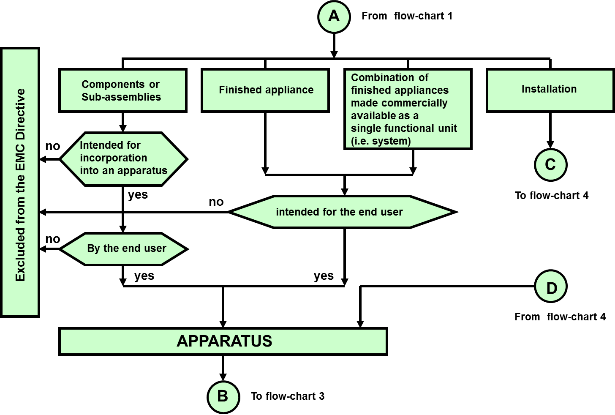

## Defining the scope of apparatus

The EMCD[22] defines "apparatus" as any finished appliance, or combination thereof made available (i.e. making available) on the market as a single functional unit[23], intended for the end-user, and liable to generate electromagnetic disturbance, or the performance of which is liable to be affected by such a disturbance.

According to Article 3(2) of the Directive "components” or “sub-assemblies” intended for incorporation into an apparatus by the end-user and "mobile installations" are also deemed to be apparatus.

One of the pre-conditions in order to be considered apparatus in the sense of the EMCD is that it is intended for the end-user. In the context of this Guide end-user means any natural person (e.g. consumer) or legal entity (e.g. enterprise) using or intending to use the apparatus for its intended purpose.

Generally an end-user is deemed to have no qualifications in the field of electromagnetic compatibility.

Another caveat is that the apparatus should be liable to cause electromagnetic disturbances, or its normal operation may be affected by such disturbances. If both of these conditions are not fulfilled due to inherent characteristics of the apparatus, then the apparatus may be considered as inherently benign in terms of electromagnetic compatibility, and hence, the EMCD does not apply (see section 1.4.4).

Flowchart 3 summarises the provisions applicable to apparatus (see chapter 4 and section 5.4).

Flowchart 3 - Provisions applicable to apparatus

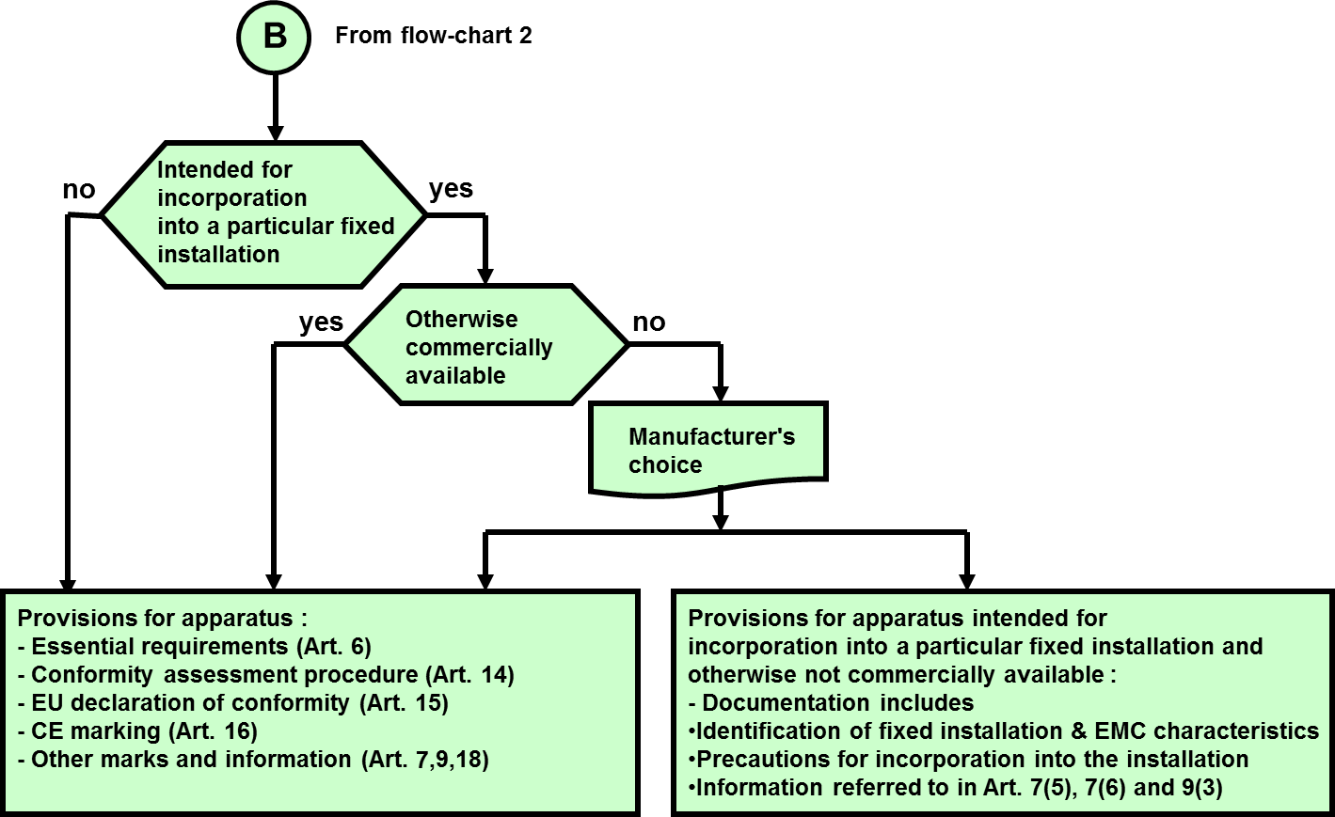

### Finished appliances

**A finished appliance is any device or unit that delivers a function and has its own enclosure.**

A finished appliance is considered as apparatus in the sense of the EMCD, if it is **intended for the end-user** and thus has to fulfil all the applicable provisions of the Directive. If the finished appliance is made available on the market the requirements of the EMCD has to be fulfilled.

### Several products

To be finalised

### Components/Sub-assemblies

In contrast to finished appliances, components /sub-assemblies do not, in general, have a proper enclosure intended for their final use. Components/sub-assemblies are often intended to be fitted into or added to an apparatus in order to add an additional function.

Under Article 3.2.1 of the EMCD, components/sub-assemblies are covered by the EMCD, if the following two criteria are satisfied:

1. intended for incorporation into an apparatus by the end-user; and
2. liable to generate electromagnetic disturbance or the performance of which is liable to be affected by such disturbance,

Based on the definitions of 'placing on the market' and 'making available on the market' (Article 3 of the EMCD), as interpreted by the Blue Guide, supplying a product is only considered as making available on the Union market, when the product is intended for end use on the Union market. Thus, the first criterion (paragraph a), which refers to the end user and hence to the end use, is satisfied once the components/sub-assemblies are considered as being 'placed on the market'.

The second criterion (paragraph b) is satisfied if the components/sub-assemblies are liable to generate electromagnetic disturbance or is liable to be affected by such disturbance. At least any of the two situations need to be satisfied. Benign components/sub-assemblies are excluded, thus not covered by the EMCD[24] (see also section 1.4.4 of this Guide).

The instructions for use accompanying the component or sub-assembly should include all relevant information and should assume that adjustments or connections can be performed by an end-user not aware of the EMC implications.

Illustrative examples of EMC components/ sub-assemblies covered by the EMCD, if placed on the EU market:

1. Plug-in cards for computers;
2. Programmable logic controllers;
3. Electric motors (except for induction motors without electronic circuits, see section 1.1.4);
4. Computer disk drives;
5. USB memory sticks, SD cards;
6. Power supply units where they take the form of autonomous appliances or sold separately for installation by the end-user;
7. Electronic temperature controls.

### Mobile installations

Mobile installations (e.g. mobile LED videowalls) which are defined as a combination of apparatus (and where applicable other devices) intended to be moved and operated in a range of locations are deemed to be apparatus. All provisions of the EMCD, as defined for apparatus, apply to mobile installations, unless they fall within any of the exclusions of the EMCD.

## Defining the scope for fixed installations

### Fixed installations

"Fixed installation", is defined as "a particular combination of several types of apparatus and, where applicable, other devices, which are assembled, installed and intended to be used permanently at a predefined location.”

“Fixed installation” is thus an all-encompassing term that applies, for example, to the smallest residential electrical installation through to national electrical or telephone networks, including all commercial and industrial installations that have been constructed with the intention of being permanent

The EMCD excludes “inherently benign” installations. However, “*a- priori”* application of this exclusion criterion to a predefined type of installation seems problematic and such an exclusion can only be made on a case–by-case basis.

Examples of fixed installations:

Industrial plants, power plants, power supply networks, telecommunication networks, cable TV networks, computer networks, airport luggage handling installations, airport runway lighting installations, automatic warehouses, skating hall ice rink machinery installations, storm surge barrier installations (with the control room etc.), wind turbine stations, car assembly plants, water pumping stations, water treatment plants, railway infrastructures, air conditioning installations.

Further guidance on fixed installations is provided in Chapters 2 and 5.

Flowchart 4 - Installations

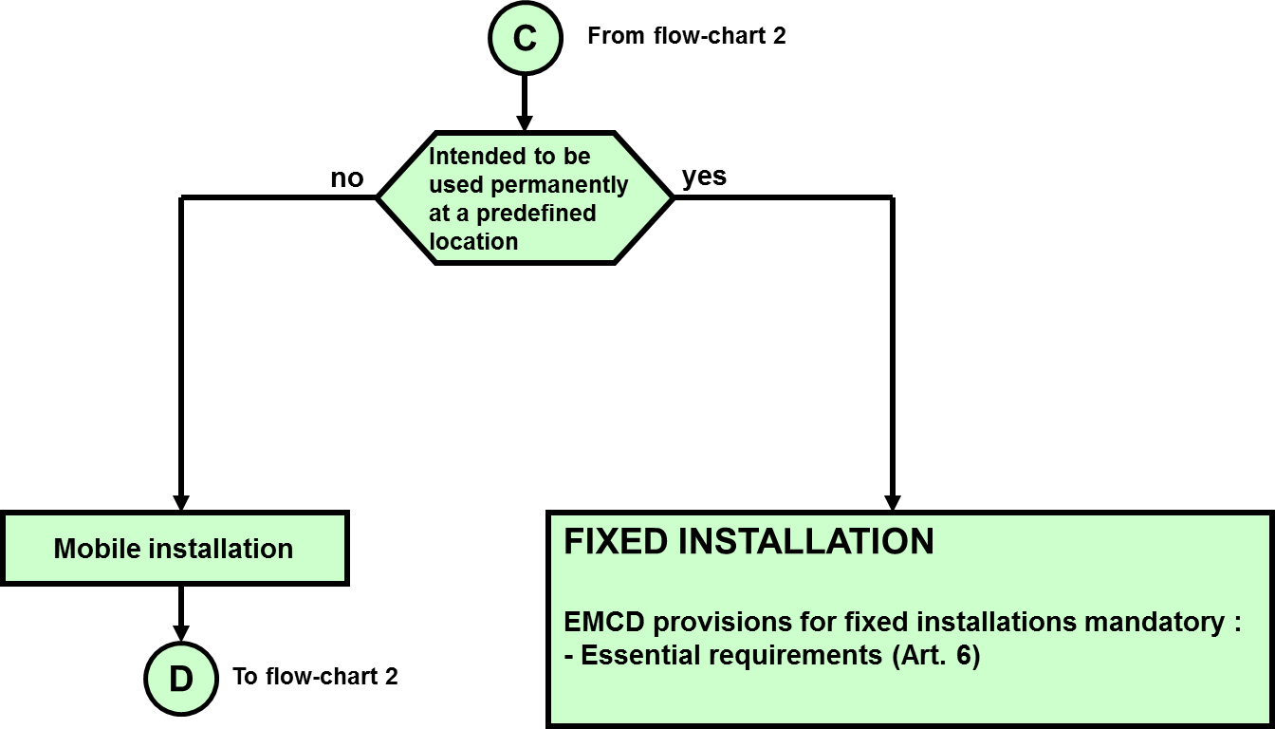

### Specific apparatus for fixed installations

In general, apparatus that will be incorporated into fixed installations need to comply with all of the provisions of the EMCD. However, the EMCD provides an exception for apparatus intended for incorporation in a **particular fixed installation** and otherwise not made available on the market.

Additional information on the requirements for specific apparatus is given in section 5.4.

## Specific Case: Jammers

A jammer is covered by the EMCD, unless if it falls within the scope of the RED. Since jamming is inherent to their functional principle, normally it is not possible to construct jammers that fulfil the EMC essential requirements. Hence, a jammer should be prohibited or restricted from being made available or withdrawn or recalled.

# Essential requirements

The EMCD sets out mandatory “essential requirements” formulated in a general manner for all equipment (e.g. apparatus and fixed installations) within its scope. These essential requirements define the results to be attained, but do not specify the detailed technical requirements. It also allows adapting the equipment and product design as a result of technological progress. The appropriate technical solutions to meet the requirements are not imposed as long as the equipment complies with the essential requirements.

The essential requirements lay down the necessary elements for protecting public and general interest.

Compliance with the essential requirements is mandatory. These are legally-binding for all equipment in the scope of the EMCD. Only compliant equipment may be placed on the market and/ or put in service in the Union.

The essential requirements are split into two parts:

“General requirements” for all equipment (e.g. apparatus and fixed installations). These general requirements cover all relevant EMC phenomena for both emission and immunity.

“Specific requirements for fixed installations”.

# obligations of economic operators

Guidance on the basic obligations of economic operators can be found in the Blue Guide chapter 3 “the actors in the product supply chain and their obligations”. EMC specific obligations are to be found in chapter 4 of this EMC Guide.

# CONFORMITY ASSESSMENT Procedure for apparatus

## Introduction

Apparatus shall comply with the essential requirements referenced in Article 6 and detailed in Annex I of the EMCD. Compliance with these essential requirements shall be demonstrated by applying one of the conformity assessment procedures referenced in Article 14 and detailed in Annex II and Annex III of the EMCD.

Technical documentation shall be prepared by the manufacturer to demonstrate evidence of compliance with the essential requirements. This includes evidence that the apparatus complies with the relevant harmonised standards or, if harmonised standards are not used or only used in part, a detailed technical justification including a list of other relevant technical specifications applied.

The manufacturer shall take all measures necessary to ensure that the apparatus are manufactured in accordance with the technical documentation[25] The manufacturer may involve a Notified Body during the conformity assessment procedure which is set out in Annex III (when module B + C, ie Annex III, is chosen the manufacturer shall ensure that the apparatus is manufactured in conformity with the type described in the EU-type examination certificate).

The manufacturer shall also draw up an EU Declaration of Conformity and affix the CE marking on the product or, if not possible due to the nature or the size of the product, on the packaging and accompanying documentation.

Flowchart 5 - Conformity assessment procedure for apparatus

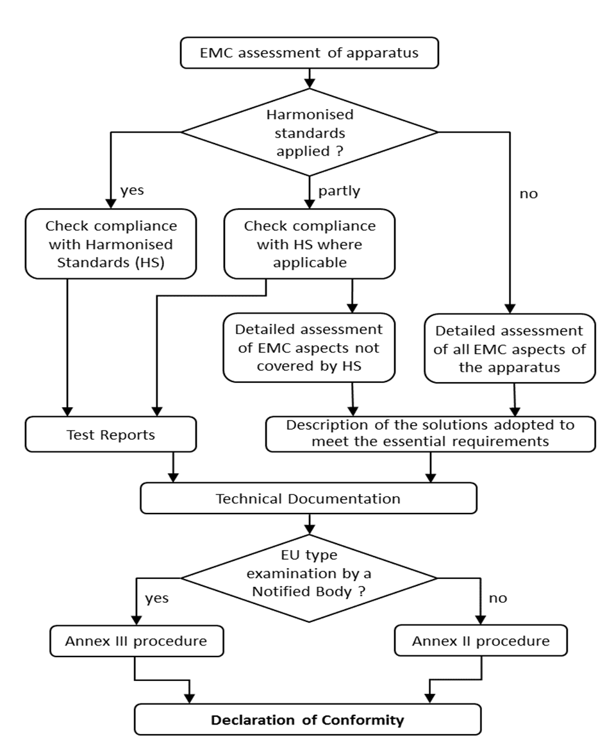

## Risk analyses and risk assessment

The conformity assessment procedures for apparatus require the manufacturer to establish technical documentation. This documentation shall make it possible to assess the conformity of the apparatus to the relevant requirements, and shall include an adequate analysis and assessment of the risk(s). In EMCD the concept of risk refers to risks in relation to the electromagnetic compatibility protection aims specified in Annex I “Essential Requirements” and not to safety. On basis of the knowledge of the relevant EMC phenomena for the apparatus and its intended operating environments the EMC assessment according to chapter 4.3 can be performed. This EMC assessment is considered to be an adequate analysis and assessment of the risk(s). See also Blue Guide section 4.1.1 "Definition of essential requirements".

## EMC Assessment

### 4.3.1 General Concept

The manufacturer shall perform an EMC assessment of the apparatus[26] based on the relevant phenomena in order to ensure that he meets the essential requirements. As noted above the EMCD does not require the **mandatory** intervention from a third party (e.g. notified body or laboratory) when carrying out the assessment.

The manufacturer is fully responsible for applying the appropriate method of assessment. Recommendations are given in this Guide to help in this process.

Where the EMC assessment establishes that the apparatus concerned is inherently benign in terms of electromagnetic compatibility (both for emission and immunity) according to Article 2(2d), the apparatus is excluded from the scope of EMCD and no further actions are necessary. However, it is recommended to document the results of the assessment and its conclusion.

The EMC assessment needs to take into account all normal intended operating conditions of the apparatus.

In cases where the apparatus can take different configurations, the electromagnetic compatibility assessment confirms that the apparatus meets the essential requirements, “in all possible configurations identified by the manufacturer as representative of its intended use”**.** [27]

In practice, this EMC assessment has to be performed following a defined methodology.

Any conformity assessment procedure requires the manufacturer to start a risk analysis of the specific risks of the product to address them in order to comply with the essential requirements because not all products present the same risks.

Once these risks are identified and the manufacturer is determining the measures to address those risks in order to comply with the essential requirements he can choose to apply the harmonised standards.

After having identified the risks of the apparatus, three methods are possible for the EMC assessment:

1. Application of EMC harmonised standards having checked whether the chosen harmonised standard(s) covers all the phenomena relevant to the product.
2. An EMC assessment where no harmonised standards have been applied and the manufacturer applies his own methodology (other technical specifications).
3. Mixed assessment, combining the two previous methods. For example, one could use the harmonised standards to cover emission phenomena and a detailed technical EMC assessment for immunity aspects.

Harmonised standards (see the definition in the relevant chapter of the blue guide) provide a recognised methodology to demonstrate compliance to the essential requirements and are usually the preferred way to demonstrate compliance. The manufacturer may ask a third party to perform the EMC assessment for him or help him with part of it, but the manufacturer is and remains fully responsible for the compliance of his apparatus with the provisions of the Directive.

To re-iterate - **the EMC assessment is the sole responsibility of the manufacturer**; it is never the responsibility of a third party such as a Notified Body or an EMC test laboratory[28].

Where a manufacturer assembles a final apparatus using components from other manufacturers, the manufacturer of the final apparatus must retain overall control and is responsible for the compliance of the final apparatus[29].

#### 4.3.1.1 The “Worst Case” approach

Where apparatus can take different configurations, the EMC assessment shall confirm that the apparatus meets the essential requirements in all of the configurations foreseeable by the manufacturer as representative of normal use in intended applications.

The manufacturer is responsible for identifying the possible configurations and the choice of the worst case(s). The use of the worst case approach needs to be documented in the technical documentation[30].

4.3.2 Use of EMC harmonised standards

Harmonised standards are European standards that have been adopted on the basis of a request made by the Commission for the application of Union harmonisation legislation (for example the EMC Directive).

Compliance of the harmonised standards with the EMC requirements (as listed in the current consolidated list published in the OJEU) gives presumption of conformity with the corresponding essential requirements of the EMCD.

Each harmonised standard contains information (including a table) on how to achieve the presumption of conformity with the corresponding essential requirements of the EMC Directive.

The EMCD refers to the moment of placing on the market for each individual apparatus[31]. This means that for apparatus which is continuously produced over a long period, the applicable standards may change in the course of time. In this case the provisions explained at 4.3.2 concerning the reference of the superseded standards and the date of cessation of Presumption of Conformity should be taken into account. The Date of Cessation ensures that a transition period (usually between 18 and 36 months) is foreseen during which either the old or the new harmonised standards may be used, at the choice of the manufacturer, to benefit from Presumption of Conformity.

After this time if the manufacturer wishes to continue to benefit from the Presumption of Conformity and the apparatus is not yet placed on the EU market, the apparatus needs to conform to the later harmonised standard and a new EU Declaration of Conformity is required to include the reference to it (which is often a later edition/version with the same reference number). This will require the manufacturer to make an EMC evaluation to the later harmonised standard and he may consider it necessary to carry out some re-testing.

However, it may be that the manufacturer wishes to continue to meet the essential requirements by continuing to use of the “old” edition (that has ceased to be harmonised) plus other technical solutions if necessary.. As harmonised standards are voluntary this is of course an acceptable solution but would not give the presumption of conformity that application of the later edition would confer. In this case, the manufacturer has the obligation to demonstrate that his products are in conformity with essential requirements with the means he has chosen.

Where new editions become available and are to be applied it does not necessarily mean that a complete EMC re-assessment of an existing product is necessary. The evaluation may be restricted to those modifications directly affecting the apparatus concerned. For example, the change may only relate to a small range in scope, or one particular clause or phenomenon.

Harmonised standards under the EMCD are drawn up and adopted by the three European Standardisation Organisations (ESO) recognised in the Standardisation Regulation[32]:

* European Committee for Standardization (CEN)
* European Committee for Electro technical Standardization (CENELEC)
* European Telecommunications Standards Institute (ETSI)

Detailed information on the general EU policy regarding harmonised standards is available at the web-site of the European Commission.

#### 4.3.2.1 List of harmonised standards

The list of harmonised standards published in the OJEU is regularly updated. The European Commission publish a link to the relevant edition of the OJEU on their web page relevant to the EMC Directive.

Information on standards is also available on the CENELEC, ETSI and CEN web-sites:

www.cenelec.eu

www.etsi.org

www.cen.eu

In order to obtain the text of CEN or CENELEC standards, you should contact the national members of CEN or CENELEC or the standardisation body of your country if you are located outside the territory of CEN/CENELEC members.

A list of members of CENELEC is available at: <http://www.cenelec.eu/>

ETSI standards can be downloaded from the ETSI web-site without cost and are sometimes distributed by National standards bodies or third parties.

Further guidance for the application of harmonised standards is given in Annex 2.

#### 4.3.2.2 Relevant harmonised standards

The selection of the appropriate harmonised standards is the responsibility of the manufacturer.

When the manufacturer chooses to apply harmonised standards he shall select them in the following precedence order:

* + Product-specific standards (if available)
  + Product family standards (if available)
  + Generic standards

Product-specific (family) standards are those written by ESO’s taking into account the environment, operating and loading conditions of the equipment and are considered the best to demonstrate to compliance to the Directive.

Generic standards could be used in the absence of either product-specific or product-family standards. They are divided into generic environments but do not contain specific guidance of how to operate and load equipment during the testing phase of an EMC assessment.

It may be necessary to apply several harmonised standards to cover all essential requirements of the Directive. Each harmonised standard identifies the essential requirements which it covers in an annex.

Generally the main aspects to be covered are:

* + Radiated disturbances
  + Conducted disturbances at mains and telecommunication ports
  + Immunity to continuous radiated and conducted disturbances
  + Immunity to transient phenomena

Applying several standards may be necessary to address all relevant phenomena in all relevant frequency ranges. For multi-function apparatus, it may also be necessary to select standards relevant to all primary functions.

Useful practical information on the selection of the appropriate CENELEC standards may be found in the CENELEC Guide 25 ”Use of EMC standards for the application of the EMCD” which is available on the CENELEC website. The CENELEC Guide 24, also available on the same website, explains the general structure of the EMC standardisation and the respective roles of EMC standards, e.g. basic standards, generic and product (family) standards.

### 4.3.3 An EMC assessment where no harmonised standards have been applied

A manufacturer may wish to declare the conformity of his apparatus directly to the essential requirements, without reference to harmonised standards, by addressing the EMC risks with other means. If the manufacturer chooses not to follow the harmonised standards, he has the obligation to demonstrate that his products are in conformity with the essential requirements by the use of other means of his own choice (Blue Guide, paragraph 4.1.3 Conformity with the essential requirements: Other possibilities). This assessment needs to follow a technical methodology to ensure that the requirements of the EMC Directive are met. The manufacturer will need to provide clear evidence of compliance.

This option allows flexibility for technical development, crucial when manufacturers of new or innovative apparatus for which standards do not exist, or cannot be used, want to assess their apparatus according to the essential requirements.

This is usually the case where:

* There are no harmonised standards or where they do not cover all the essential requirements applicable to the apparatus;
* The apparatus uses technologies, incompatible with or not yet taken into account by harmonised standards, and generic standards are not applicable;
* The manufacturer uses test facilities not yet covered by the harmonised standards;
* The manufacturer may want to apply any other standards or specifications not harmonised in the context of the EMCD;
* The apparatus is physically too large to be tested in the facility described in the harmonised standard or where “in-situ” testing is foreseen and not adequately covered by a harmonised standard.

The assessment required for a particular apparatus will depend on several factors, such as:

* Nature of the apparatus (apparatus characteristics);
* Intended use;
* Location of use; EMC environment
* Types of disturbances created by or affecting the apparatus;
* Environmental conditions;
* Performance criteria for immunity.

The EMCD requires the manufacturer to document all steps taken and decisions made to check the conformity of the apparatus for those aspects for which the manufacturer has chosen this method of assessment. It may encompass (but is not limited to) the following:

Description and definition of the apparatus operating conditions and its intended purpose. This should also cover the power supply voltage and frequency aspects relevant to the apparatus;

* Specification, descriptions and classification of the environments in which the apparatus will be used. This may cover also aspects relevant for apparatus that may be moved and must have emission and immunity characteristics appropriate for several environments. This selection is the responsibility of the manufacturer based on knowledge of the electromagnetic environment and awareness of the statistical aspects involved;
* Clear specification of relevant sources and effects of the electromagnetic phenomenacovered and compatibility levels applied;
* Specification of the performance criteria of the apparatus. These should be set taking into account of the reasonable expectations of the user;
* Test levels with regard to the immunity of the apparatus;
* Limits adopted for emission, etc.;
* Reference to available documents such as any harmonised standards, recommendations;
* Indication of any deviations made to available reference documents. These deviations may concern the phenomena considered, tests methods, test facilities or test levels, etc.;
* EMC design considerations and/or calculation results;
* Statistical evaluations, theoretical studies or other examinations carried out, presenting background theory, arguments, results and conclusion. This may include information on the levels of occurrence and statistical distribution of the disturbances;
* Description on how components are selected;
* Information on shielding, cable screening and routing, filters, ferrites etc;
* Any description of the solutions adopted in order to comply with the essential requirements, including the list of the relevant technical specifications applied;
* Any specification of general or specific requirements taken to limit emission of disturbances;
* Assessment of whether compliance with the essential requirements is ensured in residential areas or not. If this is not the case the restriction of use shall be clearly established;
* Assessment of whether any specific precautions have to be taken when the apparatus is assembled, installed, maintained or used, in order to ensure that, when put into service, the apparatus is in conformity with the essential requirements;
* Worst case selection criteria for series of apparatus with similarities

Detailed guidance on the selection of electromagnetic phenomena to be assessed in the EMC assessment is given in Annex 3 to this Guide.

Reference sources of information for the manufacturers undertaking this method of assessment may continue to include harmonised standards, their drafts as well as standards related to EMC but not harmonised under the Directive e.g. basic EMC standards.

**To-reiterate, where this route is chosen the apparatus does not benefit from a presumption of conformity.**

## Documentation required by the EMCD

The documentation required by the EMCD comprises of the technical documentation and the EU Declaration of Conformity

### Technical documentation

The manufacturer draws up the technical documentation providing evidence of the conformity of the apparatus with the essential requirements of this Directive, regardless if the Annex II “internal production control” or Annex III “EU-type examination that is followed by Conformity to type based on internal production control” was chosen.

The purpose of the technical documentation is to make possible to assess the conformity of the apparatus to the relevant requirements, and shall include an adequate analysis and assessment of the risk(s). It must contain all necessary practical (technical) details, including the following:

* an identification of the product covered by the technical documentation. This identification should allow unambiguously linking between the technical documentation, the EU Declaration of Conformity and the product;
* a general description of the apparatus. The amount of information required will depend on the complexity of the apparatus, simple apparatus may be fully defined in one line whereas more complex apparatus may need a complete description (a picture may be included);
* conceptual design and manufacturing drawings and schemes of components, sub‑assemblies, circuits, etc. Section 4.3 "Technical documentation" Blue Guide 4th paragraph.
* descriptions and explanations necessary for the understanding of those drawings and schemes and the operation of the apparatus;
* if harmonised standards have been applied then evidence of compliance is required. At a minimum this will be a dated list of the European harmonised standards applied and the results obtained on their application;
* if harmonised standards have not been applied or have been applied only in part then a description of the steps taken to meet the essential requirements – an EMC Assessment described in Annex II of the Directive - must be included. In that event the technical documentation shall specify which parts of the harmonised standard have been applied. A list of other technical specifications used shall be included in case where harmonised standards are not used. The documentation includes test reports, design calculations made, examinations carried out etc.;
* if a manufacturer is using the procedure of Annex III of the EMCD, then the Notified Body EU-type examination certificate shall be included.

Referring to Article 7 (9) of the EMC Directive as well as chapter 3 "The actors in the product supply chain and their obligations" of the Blue Guide the manufacturer shall, further to a reasoned request from a competent national authority, provide all the information and documentation in paper or electronic form necessary to demonstrate the conformity of the apparatus with this Directive, in a language which can be easily understood by that authority.

### EU Declaration of Conformity

The compliance of apparatus with all relevant essential requirements is declared by an EU Declaration of Conformity (DoC) issued by the manufacturer - inside or outside the EU - or his authorised representative in the EU. As the DoC is an "official" declaration it must be signed by a person empowered to bind the manufacturer or his authorised representative.

By drawing up the EU Declaration of Conformity, the manufacturer shall assume responsibility for the compliance of the apparatus with the requirements laid down in this Directive.

The Directive specifies in Annex IV the model structure of the DoC as follows.

* Apparatus model/Product (product, type, batch or serial number);
* Name and address of the manufacturer or his authorised representative
* That the EU Declaration of conformity is issued under the sole responsibility of the manufacturer;
* Object of the declaration (identification of apparatus allowing traceability; it may include a colour image of sufficient clarity where necessary for the identification of the apparatus);
* That the object of the declaration described above is in conformity with the relevant Union harmonisation legislation;
* References to the relevant harmonised standards used, including the date of the standard, or references to the other technical specifications, including the date of the specification, in relation to which conformity is declared;
* Where applicable, the notified body ... (name, number) performed … (description of intervention) and issued the certificate … (EU-type examination certificate number);
* Additional information;
* Signed for and on behalf of;
* Place and date of issue;
* Name, function and the signature.

See also section 4.4 "EU Declaration of Conformity" of the Blue Guide

In most cases, the dated references to the specifications under which conformity is declared, will be those of the harmonised standards that are applicable to the apparatus in question as listed in the OJEU. If harmonised standards have not been used or only partially, a reference to the manufacturer’s technical documentation needs to be included and a reference to any identifiable non-harmonised standards or specifications that have been applied.

The layout of the DoC can take any form as long as the model structure of Annex IV of the EMCD has followed. If any of the minimum required content is missing, the DoC is considered not complete and thus not valid and may lead to an appropriate action from the competent authorities of a Member State.

Where apparatus is subject to more than one Union act requiring an EU DoC, a single EU DoC shall be drawn up in respect of all such Union acts. That declaration shall contain the identification of the Union acts concerned including their publication references. The single EU Declaration of Conformity can be made up of a dossier containing all relevant individual EU Declarations of Conformity. If national competent authorities are requesting a EU DoC the manufacturer has to deliver this single DoC or the full set/bundle of DoC.

## CE Marking and information

### CE marking

The EMCD requires that the apparatus bears the CE marking as an attestation of compliance with the EMCD.

The CE marking shall be subject to the general principles set out in Article 30 of Regulation (EC) No 765/2008 and shall have the following format:



The CE marking shall be affixed visibly, legibly and indelibly to the apparatus or to its data plate. If it is not possible or not warranted on account of the nature of the apparatus, it shall be affixed to the packaging and to the accompanying documentation (further details on CE marking and the expressions “not possible or not warranted on account of the nature of the product” are given in the Blue Guide,section 4.5.1 "CE marking").

When use is made of the exemption provided by Article 19(1) not to apply the requirements of articles 6 to 12 and articles 14 to 18 in the case of apparatus which is intended for incorporation into a particular fixed installation and is otherwise not made available on the market, it is not allowed to affix the CE marking to this apparatus to attest compliance with the EMCD. In this case CE marking may however be required to show conformity to other Directives.

### Identifying information

The EMCD requires that apparatus be identified by “type, batch or serial number or other element allowing their identification of the apparatus”. There is flexibility in this requirement, allowing for the manufacturer to choose his own philosophy for identification of an apparatus for regulatory purposes. However, the identification of the apparatus must unambiguously correlate with the DoC and the technical documentation.

The Blue Guide gives more information as to which circumstances exemptions to the marking requirements are allowed.

Specific apparatus intended to be incorporated into a given fixed installation (using the provisions of Article 19(1)) and otherwise not made available may have this identification information in the accompanying documentation and not on the apparatus.

### Information for traceability

In order to facilitate traceability, manufacturers shall indicate their name, registered trade name or registered trade mark and the postal address at which they can be contacted. The address shall indicate a single point at which the manufacturer can be contacted.

Importers (when the apparatus is imported) shall also indicate their name, registered trade name or registered trade mark and the postal address at which they can be contacted.

All contact details shall be in a language easily understood by end-users and market surveillance authorities.

The traceability requirements shall be affixed on the apparatus itself. In cases “where that is not possible”, on its packaging or in a document accompanying the apparatus.

A comprehensive explanation and details about the traceability requirements can be found in the Blue Guide section 4.2.2 "Traceability provisions".

### Information concerning the use of apparatus

Apparatus shall be accompanied by the following:

* Information on any specific precautions that must be taken when the apparatus is assembled, installed, maintained or used, in order to ensure that, when put into service, the apparatus is in conformity with the essential requirements of the EMCD,
* A clear indication on restriction of use in residential areas, where appropriate also on the packaging, if the compliance with the essential requirements of the EMCD is not ensured in residential areas (further details in chapter 4.5.5),
* Information required to enable apparatus to be used in accordance with the intended purpose of the apparatus shall be included in the instructions accompanying the apparatus,

in a language which can be easily understood by consumers and other end‑users, as determined by the Member State concerned. Such instructions and information, as well as any labelling, shall be clear, understandable and intelligible.

Apparatus may need assembling or special consideration in respect of its installation for it to comply during use with the essential requirements of the Directive. Therefore all information necessary for correct assembly, installation and use has to be provided, see also Blue Guide section 3.1 under point 4 (Manufacturer). If no information is given with the apparatus it is presumed that users can install and use the apparatus without any special considerations regarding the EMC aspects, and the apparatus will still comply with the essential requirements of the EMCD..

Examples of cases where it is relevant to provide more detailed information:

* If there are any particular earthing aspects related to the apparatus for EMC purposes, recognising of course that earthing for safety purposes cannot be compromised;
* Where the apparatus is connected to other apparatus there may be a need to have specific types of cables and connectors (e.g. screened, double screened, etc). If so this must be specified to allow for proper installation and use.

Any precaution that needs to be observed for the apparatus to maintain its compliance with the essential requirements regarding use and maintenance needs to be indicated.

### Information when compliance is not ensured with essential requirements in residential areas[33]

The EMCD recognises that the electromagnetic environment of residential areas needs particular attention. In such areas, broadcast receivers may be expected to be used in close proximity to other apparatus.

The EMCD requires that apparatus for which compliance with the essential requirements in residential areas is not ensured by the manufacturer (for example if there are limits for the residential environment in standards which are exceeded) shall be accompanied by a clear indication of this restriction of use, where appropriate also on the packaging. A clear indication may, for example, take one of the following forms (decided by the manufacturer on the basis of the severity of a potential problem if the apparatus is used in such locations):

* This product must not be used in residential areas.
* This product may cause interference if used in residential areas. Such use must be avoided unless the user takes special measures to reduce electromagnetic emissions to prevent interference to the reception of radio and television broadcasts.

The descriptions used in harmonised standards (for example “this is a class A product”) are not suitable without further explanation, as they are not understood by the general public.

The information should be included on the packaging (if present) and may be restricted to the languages used elsewhere on the packaging. The information should also be included in the accompanying documentation for example instructions for use, in each of the languages in which instructions are provided.

# Fixed Installations

## Essential Requirements

*"Fixed installation" means a particular combination of several types of apparatus and, where applicable, other devices, which are assembled, installed and intended to be used permanently at a predefined location*

Owing to their characteristics fixed installations are not subject to the need for free movement within the Union. Therefore, they are not subject to the requirements for CE marking, DoC or for formal EMC assessment before putting into service. However, fixed installations have to comply with the essential requirements and other specific requirements (Annex I of the Directive) which are applicable to them.

Measures are prescribed in the EMCD to enable the competent authorities to handle complaints concerning disturbance generated by fixed installations[34].

A fixed installation may be assembled by the incorporation of several apparatus including specific apparatus as described in Article 19.1 and other devices outside the scope of the EMCD.

Most apparatus making part of a fixed installation should be subject to all provisions applicable to apparatus under the EMCD. However, there is a possibility of exemption detailed in Article 19(1) of the EMCD under certain conditions (See sections 1.6.2 and 5.4 of this Guide).

The specific essential requirements specify that fixed installations need to be installed taking account of good engineering practices and of the information provided by the respective manufacturers regarding the intended use of the components that make up the fixed installation. This is to comply with the essential requirements which are expressed in an identical way for fixed installations as for apparatus.

The two basic requirements relating to the use of components and to good engineering practice can be summarised as follows:

Intended use of components

This means that all the EMC instructions given by the manufacturer for all the component sub-parts used in the fixed installation have to be taken into account. This applies to any sub-part, whether those parts are large machines, apparatus, components not subject to the EMCD, specific apparatus for the fixed installation, etc.

Since a fixed Installation is installed in a pre-defined location the instructions for use should ensure that the components are installed in this specific location.

For example, these instructions may concern:

* the specified environment (especially the EMC environment);
* the required use of additional auxiliary devices (protection devices, filters etc);
* the specifications and length of the cables required for external connections;
* the conditions for use;
* Any special precautions for EMC (equipotential earthing etc.).

Good engineering practice

Good engineering practice comprises of suitable technical behaviour taking account recognised standards and codes of practice applicable to the particular fixed installation. The “good engineering practices” referred to in Annex I, 2 mean practices which are good for EMC purposes, at the specific site in question.

General information on good engineering practice within the context of installations is available in several EMC handbooks, courses and technical reports. For example some technical reports published by standardisation bodies deal with installation and mitigation guidelines for EMC.

Good engineering practice, particularly in the field of EMC, are in constant evolution. Whilst there is a need to have regard for the ‘state of the art’ practices it does not necessarily follow that they are relevant for all installations. Standards for installations cannot cover all specific local conditions: therefore it is necessary to be aware of some guiding principles when aiming to demonstrate installation according to good engineering practices:

- Emissions: take appropriate actions to mitigate the source of disturbances by EMC design, e.g. by the addition of filters or of absorption devices etc.

- Coupling and radiation: take appropriate actions in respect of distances, equipotential earthing, selection of cables, screening etc.

- Immunity: take appropriate actions to ensure that sensitive equipment is protected against the various types of disturbances that might be expected.

When applying the essential requirements to a defined fixed installation, it is essential to define the borderlines/geographical limits of this fixed installation in order to distinguish it clearly from the external environment.

In an analogy with apparatus, it is fundamental to identify:

* The ports/interfaces where conducted (high or low frequency) disturbances may cross the borderline from or towards the fixed installation (power supply port, control and telecommunication ports etc.);
* The coupling mechanism with the external environment;
* The radiation towards or from the external environment.

It should be noted that it is not the purpose of the EMCD to ensure electromagnetic compatibility between specific equipment inside the borders of the defined fixed installation.

## Documentation

The level of detail of the documentation may vary from very simple information to much more detailed documentation for complex installations involving important potential EMC aspects. Where installations are comprised solely of apparatus placed on the market in conformity with the EMCD and carrying the CE marking, the responsible person satisfies the documentation requirements placed on him by being able to provide, on request, the instructions for installation, use and maintenance provided by the supplier of each apparatus. Examples of types of installations to which these documentation requirements might apply are Solar/PV Installations and domestic heating and cooling systems.

## Responsible person for fixed installations

Member States are responsible for establishing provisions to identify such persons who are responsible for a fixed installation[35].

## Requirements for specific apparatus for given fixed installations

The general principle is that all apparatus are subject to all the relevant provisions of the EMCD. However, the EMCD provides at Article 19(1) the possibility of exception for apparatus intended for incorporation in a given fixed installation and which are otherwise not commercially available.

An apparatus can only benefit from this exemption if there is a direct link between the manufacturer of that specific apparatus and the owners, installers, designers, operators or responsible persons of the fixed installation for which that specific apparatus is intended. A link provider-customer is required.

For the specific apparatus which may benefit from this exemption, the essential requirements for those apparatus considered in isolation, the conformity assessment procedure for apparatus, the subsequent EU Declaration of Conformity and the specific marks and information for apparatus are not compulsory.

Specific apparatus for which use is made of this exemption may not bear the CE marking for EMC purposes.

This exemption is extra-ordinary and that it is only provided on a case-by-case basis. However, the reader’s attention is brought to the final sentence of recital (32) which states:

“Should apparatus be incorporated into more than one identical fixed installation, identifying the electromagnetic compatibility characteristics of these installations should be sufficient to ensure exemption from the conformity assessment procedure.”

The characteristics of the identical installations, **together with their specific locations** need to be identified alongside each unit of specific apparatus intended for incorporation. The storage of “specific apparatus” units intended for more than one fixed (identical) installation is therefore permitted so long as these conditions are fulfilled

### 5.4.1. Obligations when the exemption clause is used for specific apparatus

In the case of such specific apparatus, the following indications are required in the accompanying documentation: the type, the batch, the serial number or any other identifying information of the apparatus as well as the name and address of the manufacturer and, if he is not established within the Union, the name and address of the importer.

**The accompanying documentation has to identify the fixed installation for which the specific apparatus is intended and the electromagnetic compatibility characteristics of the fixed installation**.

Furthermore, the precautions to be taken for the incorporation of the specific apparatus, in order not to compromise the conformity of the given fixed installation, has to be given in the accompanying documentation.

# Market surveillance of the EMCD

The purpose of market surveillance is to ensure that the provisions of the EMCD are complied with across the Union. Consumers, workers and other users are entitled to an equivalent level of EMC protection throughout the single market, regardless of the origin of the product. Further, market surveillance is important for the interest of economic operators, because it helps to eliminate unfair competition.

Member States need to take all appropriate measures to ensure that equipment is placed on the market and/or put into service only if it complies with the requirements of the EMCD, when properly installed, maintained and used for its intended purpose.

This obligation is complementary to that requiring Member States to allow free movement of equipment that is in compliance with the EMCD.

Procedures and details on European harmonised market surveillance can be found in the Blue Guide chapter 7 on Market Surveillance and in the “Horizontal good practices on market surveillance”[36].

# Notified Bodies

## Introduction

Notified Bodies can carry out tasks as a Notified Body under the EMCD only for apparatus under the scope of the Directive but not for fixed installations –due to their nature- under the scope of the Directive.

Regardless of whether the manufacturer has applied harmonised standards or not, in order to cover the requirements of Article 6 of the Directive, he or his authorized representative may always request a Notified Body to involve in the conformity assessment procedure of the apparatus. The procedure is described in Annex III of the Directive (Module B, followed by Module C).

***7.2 Annex III procedure***

The Directive requires compliance when apparatus is “properly installed and maintained and used for its intended purpose”. The Notified Body should therefore note any inconsistencies between obvious uses of the apparatus and the stated intended purpose so that its EU-Type Examination may be suitably qualified and is not open to misinterpretation.

The applicant specifies which aspects of the essential requirements the Notified Body is going to assess (emission and/or immunity or just a part of one of the essential requirements, e.g. only the radiated emission requirements). In all cases the Notified Body shall assess the compliance for the aspects as requested by the applicant.

An aspect relevant to the intended purpose may be the number of units of apparatus likely to be put into service and their overall potential for harmful effects to networks or the radio spectrum or to other apparatus.

The Notified Body must prepare an evaluation report that records the technical documentation that was reviewed and the Notified Body decision(s) with regards to the technical design being adequate (or not) to meet the relevant essential requirements. If the review concludes that the documentation demonstrates compliance with the requirements of the Directive, the Notified Body can then issue an EU-Type Examination Certificate to the applicant indicating the aspects of the essential requirements that have been assessed.

In the case of the Notified Body report not coming to a positive conclusion that the apparatus concerned is satisfying the requirements of the Directive, the Notified Body shall refuse to issue an EU Type Examination certificate. The Notified Body shall inform the applicant accordingly giving detailed reasons for its refusal in the report.

A Notified Body shall follow the process in Article 32 (3) of the Directive when refuses to issue the EU Type Examination certificate and the process in Article 32 (4) and (5) when suspends or withdraws the certificate.

The Notified Body must base its EU Type Examination Certificate on the requirements of the Directive and the Notified Bodies professional assessment of the technical documentation taking due account of relevant standardisation, other technical references and professional decision available at that time.

When compliance of the apparatus is confirmed by the Notified Body report, the EU Type Examination Certificate of the Notified Body can state conditions (if any) for its validity. This could be a validity period of the Certificate or conditions on technical requirements to be specified in order for the apparatus to be compliant (such as adding a specific EMC filter to the apparatus or using a specified cable).

The Notified Body should maintain records documenting the rationale used to arrive at a particular decision. The records should identify any documents referenced in the assessment and the particular parameters applied to determine compliance with the essential requirements.

Annex III of the Directive provides for the Notified Body to give an evaluation report and an EU Type Examination Certificate based on the technical documentation reviewed. Further Annex III does provide guidance on the content of the EU Type Examination Certificate. However, a Notified Body is free to choose its own format and may include additional information such as the reference standards, intended purpose and other remarks/observations.

The Notified Body should take account of the following aspects for the EU Type Examination Certificate:

Title “(Directive 2014/30/EU -Notified Body) EU-Type Examination certificate” or similar text and avoiding the use of words such as “opinion” and “declaration”.

Insert on the Certificate:

* Notified Body Name, address etc., logo.
* Notified Body number.
* EU Type Examination Certificate number - this shall be the unique number of EU Type Examination Certificate. A revision number and/or copy number shall be included if applicable.
* Date of issue of the Certificate and its Validity
* Applicant details: Name, address etc. of the party requiring the EU Type Examination Certificate.
* Scope of examination whether the certificate is covering emission and/or immunity.
* Clear identification of the apparatus. The goal is to give the minimum information from the following list such that a third party would be able to uniquely identify the item in question.
  + Description of apparatus, including brand/trade name, model/type designation, hardware and software (where it affects the Directive conformity) revision.
  + Reference of any build status/design documentation taken into account.
  + Technical documentation identification
  + Unique identification of the documentation etc. taken into consideration irrespective of the actual physical format of the documentation
* Conclusions of the examination
* Certification text - the text stating that the apparatus is compliant.
* Authorised signatory (signature block including printed name of the signatory).

The manufacturer shall inform the Notified Body that holds the technical documentation relating to the EU-Type examination certificate of all modifications to the approved type that may affect the conformity of the apparatus with the essential requirements of this Directive or the conditions for validity of that certificate. Such modifications shall require additional approval in the form of an addition to the original EU-type examination certificate.

If the product has been subject to important changes having a significant impact on its compliance with the EMCD (EMC Characteristics of the apparatus, identification details of the apparatus etc.), then the apparatus becomes a new product entering the market. The original EU Type Examination Certificate is then not valid anymore. If for the new product the manufacturer wishes to apply Module B/C again and involve a Notified Body then he is free to choose any Notified Body for this assessment. He is not obliged to choose the original Notified Body.

## Subcontracting

The Notified Body can subcontract limited specific conformity assessment tasks or have recourse to a subsidiary, provided that the subcontractor or subsidiary also meets the requirements set out in Article 24 of the EMCD. Notified bodies shall inform the notifying authority accordingly, and agreement of the client must be obtained for activities to be performed by the subcontractor or subsidiary. The notified body remains fully responsible for the tasks performed by the subcontractor or the subsidiary.

Subcontracting does not therefore entail the delegation of powers or responsibilities. Notified Body decisions are always solely issued in the name and under the responsibility of the Notified Body (see section 5.2.5 of the Blue Guide "Subcontracting by notified bodies").

## Information exchange

Article 34 and Annex III (paragraph 8) of the Directive contain requirements for Notified Bodies to provide specific information to certain organisations such as other Notified Bodies, authorities, etc.

Notified Bodies should check the Notified Body Coordination Group – EUANB to see whether the EUANB has made available procedures to facilitate an easy exchange of information or refers to procedures available elsewhere.

## Coordination between Notified Bodies

Recognizing that it is necessary for the conformity assessment routes to be applied consistently by all parties in order to achieve an open and competitive market throughout Europe, the European Association of EMC Notified Bodies - EUANB has been set up. (See Annex 6 of this Guide)

The EUANB contributes to the effective implementation of relevant legislation in cooperation with the Working Party set up under the Directive (i.e. EMCWP) and facilitates the convergence of conformity assessment practices in the regulatory sphere. The EUANB liaises with relevant organisations such as CENELEC, ETSI and EMC ADCO.

The EUANB issues information sheets, called Technical Guidance Notes — TGNs — which have been drawn up to assist the Notified Body in its task. Furthermore EUANB provides Reference Documents solely for its members containing valuable information to support the work of the Notified Bodies.

## Complaints regarding the service provided by NB

Notified Bodies are required to have a policy and procedure for the resolution of complaints received from clients or other parties.

Where a manufacturer is dissatisfied with the service performed, he should file a complaint with the Notified Body in question.

A complaint can also be filed by the manufacturer with the national notification authority.

Where non-compliant apparatus has been subject to the conformity assessment procedure involving the service provided by a Notified Body, the authority supervising the Notified Body will need to take appropriate action and inform the Commission and the other Member States accordingly.

ANNEX 1 - Overall flowchart

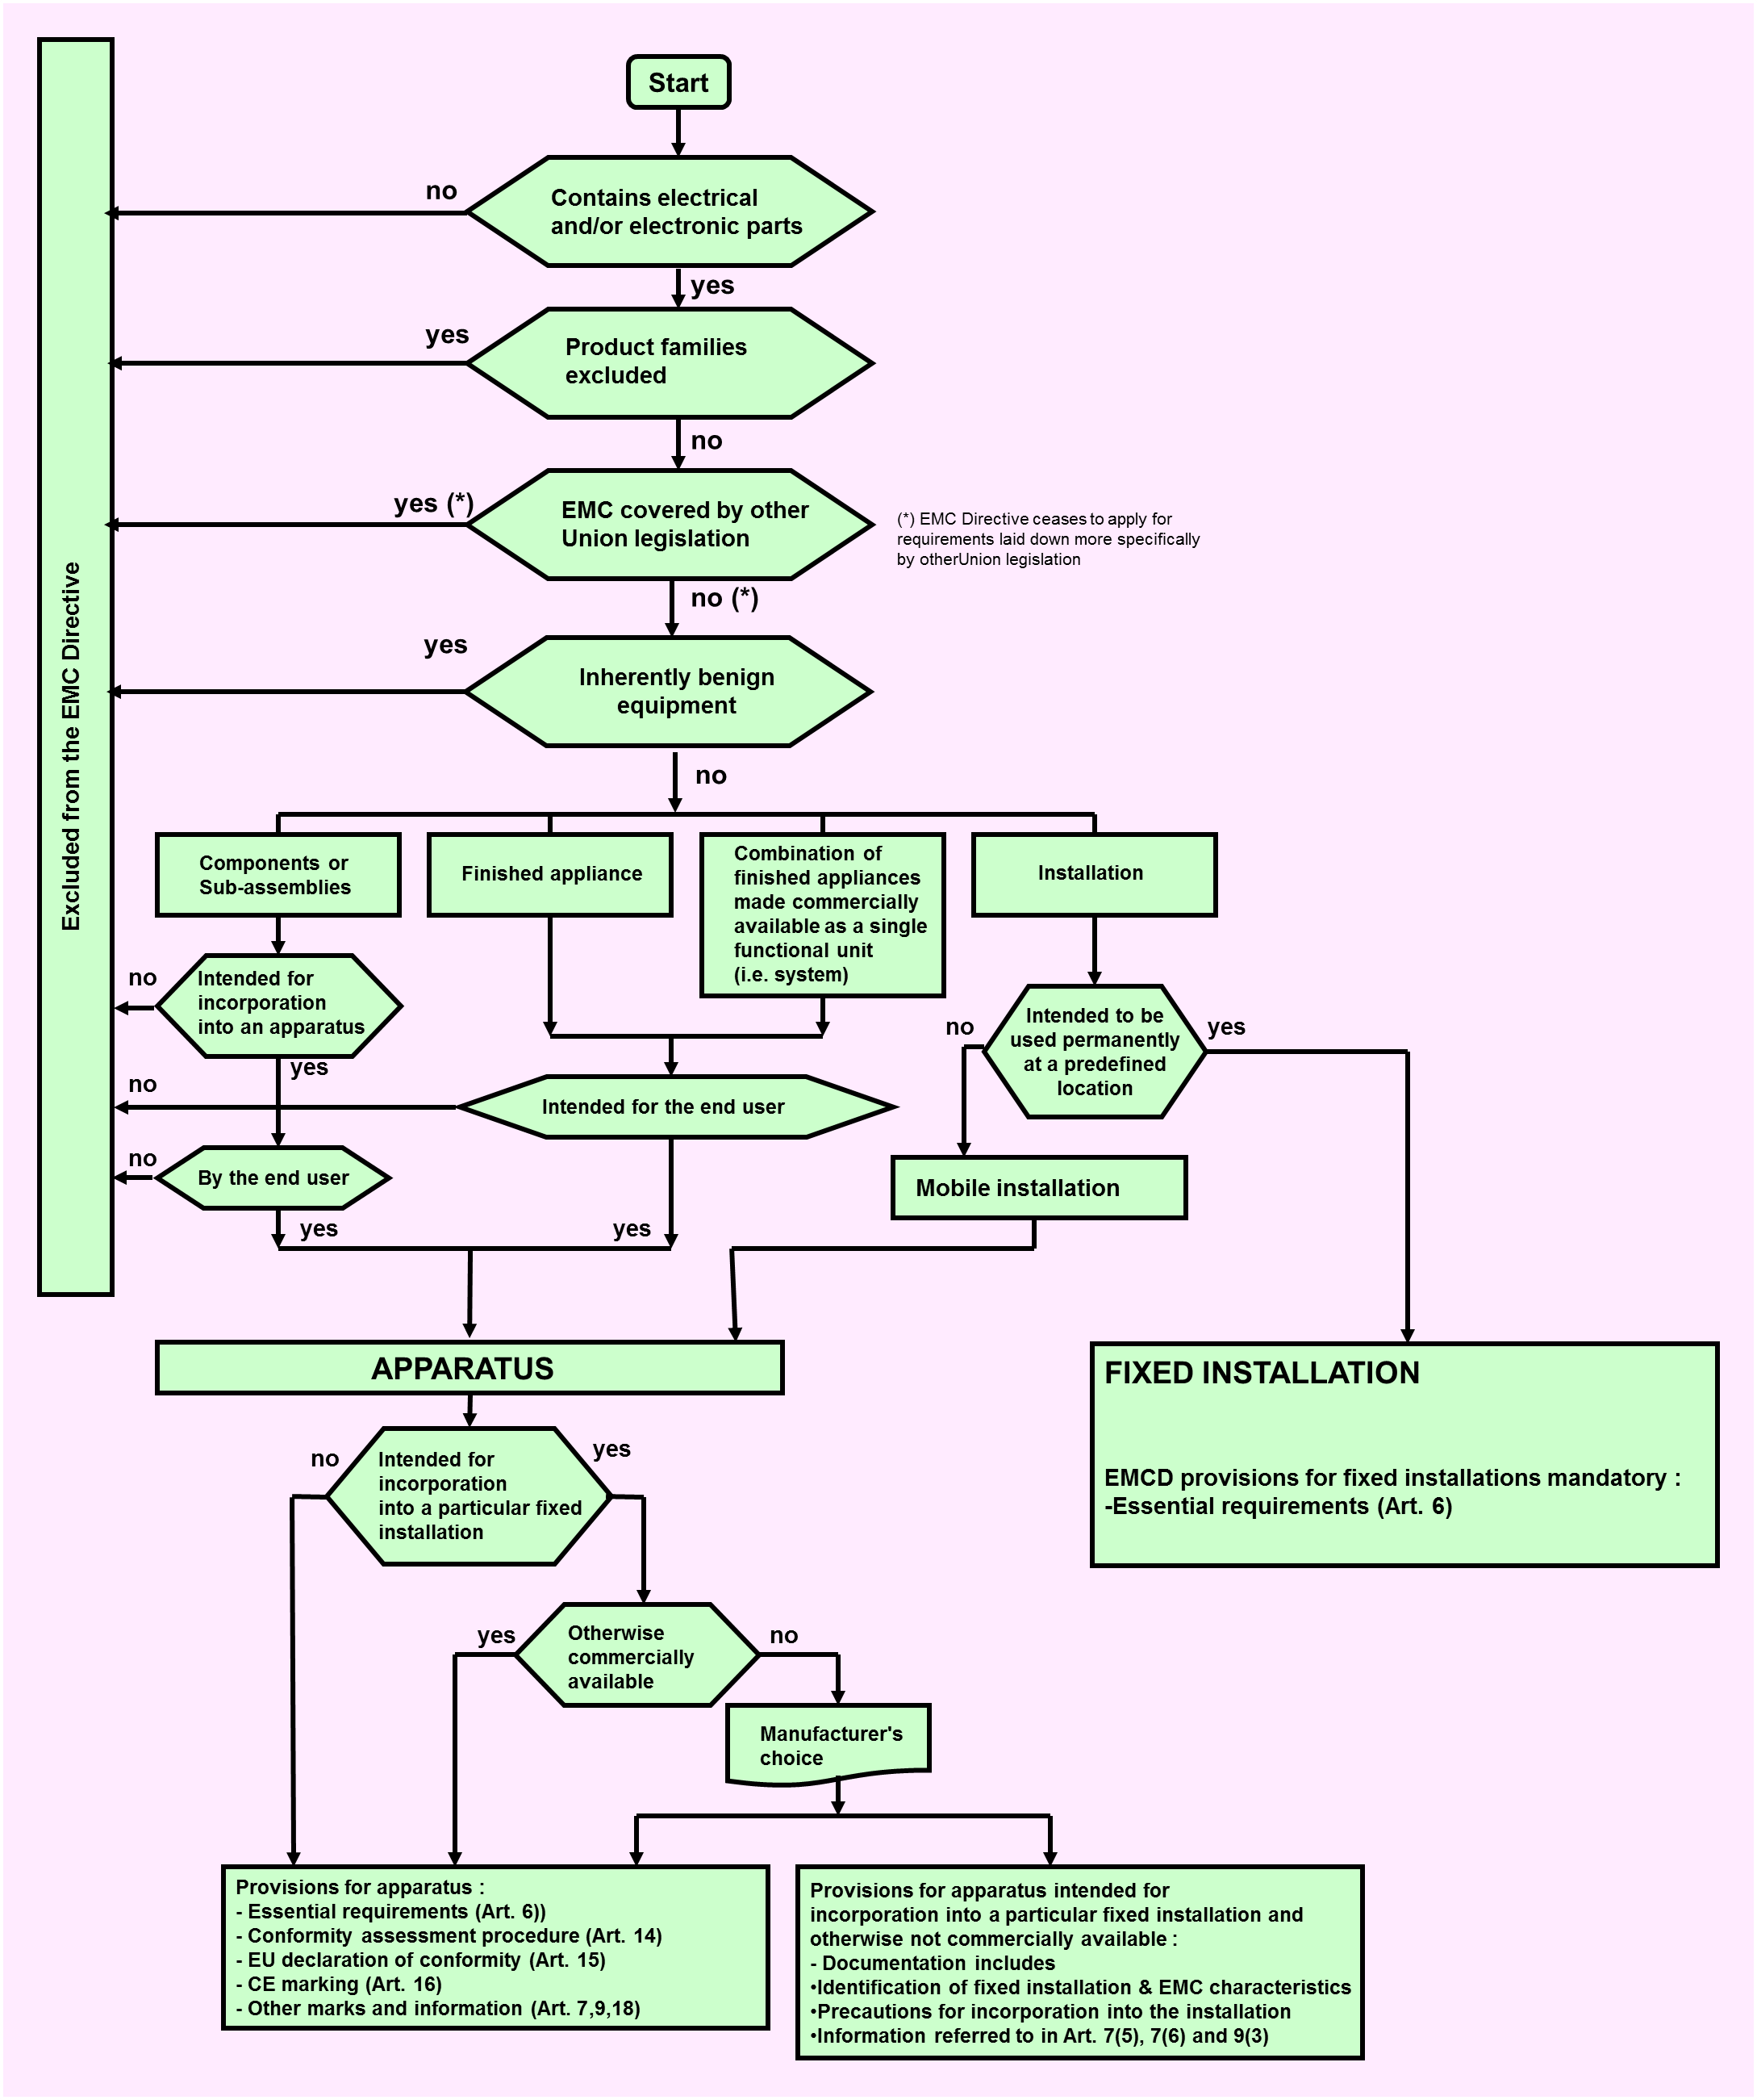

ANNEX 2 - Guidance on using a harmonised standard

Referencing a harmonised standard in a DoC means that the manufacturer takes responsibility of the conformity of their equipment with all the relevant provisions listed in the annex of that standard and that this can be demonstrated by applying the methods (tests, measurement methods, etc.) this standard describes or refers to. The harmonised standard may contain additional requirements that are not relevant to the presumption of conformity against the EMCD. The harmonised standard is required to contain an annex correlating its technical requirements with the essential requirements of the Directive.

The requirements and limits of the harmonised standard are expected to be met when the equipment is tested to the standard. Based on the risk analysis (see clause 4.2 of this document) and if the applied harmonised standard does not cover all the phenomena expected from the equipment, the manufacturer has to address the additional risks not covered by the harmonised standards to ensure that all the phenomena are considered.

The only secure way for the manufacturer is thus to apply, without any deviation, the standards referred to, relevant for its equipment, while making the EMC assessment. As most EMC standards include a series of tests with associated measurement methods, that implies in particular that all relevant tests indicated should be done exactly as required by the standard with regard to test and measurement methods.

Notes on some practices

There are circumstances where the manufacturer deviates, under their full responsibility, from the way described above. The deviations described hereafter imply a risk for the manufacturer. They have to evaluate this risk when they declare conformity to a harmonised standard by allowing themselves such deviations. The technical documentation should give detailed information on such deviations.

a) Manufacturers may decide in some cases not to perform some tests if they can satisfy themselves by other means (e.g. design precautions, comparison with similar apparatus) with sufficient certitude that the requirements of the standard will be met, if the tests were executed. They may also decide under their sole responsibility not to perform some tests if the inherent physical characteristics of the apparatus are such that negligible disturbances will occur in a given frequency band. In such cases, explanations have to be added to the technical documentation. These explanations should demonstrate on how essential requirements are met.

b) A pre-scan measurement is made to quickly obtain information on the unknown emission spectrum of the apparatus in order to decide whether a full complete measurement is considered necessary. More information may be found in EN 55016-2 (CISPR 16-2) on this particular subject. This possibility is depending on its availability in the applied Harmonised Standard.

ANNEX 3 - EMC assessment where harmonised standards do not exist or are not fully (applied)

The EMCD requires the identification of the relevant disturbances and EMC phenomena for the apparatus and the environments where it operates in order to determine the relevant assessment to be performed.

Although the EMCD does not specify a frequency range, it is general practice to take account of the range of frequency encompassed in the EMC assessment from 0 Hz to 400 GHz. This does not mean there is a need to apply a full assessment within this range as certain phenomena are limited in frequency range (e.g. for conducted high frequency emission: the frequency range to take into account is usually 9 kHz to 30 MHz). For some apparatus, electromagnetic phenomena are inherently limited in frequency range by the principle of construction or the physical nature of the apparatus.

The frequency range to be applied in the assessment depends on the nature of the apparatus and its intended use. However it is important to make sure that the relevant frequency range has been covered (e.g. taking into account the common use of radiocommunication products) in combination with the phenomena to be assessed.

The selection of phenomena to be assessed depends on the environment where the apparatus is being used.

The technology of electromagnetic compatibility has developed over a long period of time and is a fairly complex subject. The use of the radio spectrum is subject to constant changes, applying new RF technologies that may require a different protection against disturbances. An identical situation may occur for low frequency phenomena. In the field of electromagnetic immunity the sources that may create immunity problems are also constantly changing.

There exists a finite probability that the apparatus in practice will experience disturbance levels the severity of which is above those specified as characteristic of the apparatus. On the other hand it is not feasible to aim for 100 % performance in all situations, i.e. for immunity, temporary degradation in performance may be acceptable for certain apparatus.

For emissions there may be special cases, for instance when highly susceptible apparatus is being used in proximity, where additional mitigation measures may have to be employed for individual apparatus to reduce the electromagnetic emission further below any specified levels. This issue may be taken into account during the assessment.

One should be aware that the problem of electromagnetic compatibility may become worse with the trend towards smaller devices operating at higher frequencies. Higher speed switching logic increases emissions while low operating voltages and currents, with circuits packaged more closely together, decreases immunity. Furthermore the mechanisms for radiation from apparatus are complex due to the different number, nature and interaction of interference sources that are active within the apparatus.

EMC covers conducted and radiated phenomena over the whole frequency range from 0 Hz to 400 GHz and may relate to many different phenomena such as given in the following non-exhaustive list of examples.Generally the three main aspects to be covered are:

(a) Low-frequency emission on the mains supply (harmonics, voltage fluctuations) for all apparatus intended to be connected directly to low-voltage public distribution systems.

(b) High frequency emission aspects.

(c) Immunity aspects.

For the detailed technical EMC assessment the phenomena in the list need to be considered, unless it can be justified that a phenomenon is not relevant for the apparatus to be assessed. It may also be necessary in some cases to consider a phenomenon that is not listed in the list of examples.

**List of examples of electromagnetic phenomena**

|  |  |
| --- | --- |
| **Conducted low frequency phenomena** | |
| **Emission** | **Immunity** |
| Harmonics and voltage fluctuations likely to be produced on the mains supply by apparatus intended to be directly connected to the low-voltage public power distribution system. | a) harmonics, interharmonics on the mains supply  This phenomenon may be relevant to apparatus sensitive to precise zero crossing in time on the AC (Alternating Current) mains voltage or to specific harmonic components.  b) signals superimposed on power lines;  May be relevant for apparatus operating at low level of sensitivity such as residual current operated protection devices.  c) voltage fluctuations on the mains supply  In general, voltage fluctuations have an amplitude not exceeding 10 %; therefore, most apparatus are normally not disturbed by voltage fluctuations. However, this phenomenon may be relevant for apparatus intended to be installed at locations where the mains have larger fluctuations.  d) voltage dips and interruptions on the mains supply  To be considered generally for all types of apparatus. If the principle of the apparatus requires or involves a particular sensitivity to such phenomena, this should be indicated in the user documentation.  e) voltage unbalance;  Only applicable in special cases for three phase apparatus  f) power frequency variations of the mains supply  This may apply to apparatus intended to be installed at locations where the power frequency has large variations (for example apparatus connected to an emergency power supply).  g) induced low frequency voltages  For sensitive low level measuring instruments;  h) DC (Direct Current) component in AC networks.  For special cases as residual current circuit breakers |
| **Radiated low-frequency field phenomena** | |
| **Emission** | **Immunity** |
| Generally not relevant | a) magnetic fields  1) continuous;  2) transient;  In general only relevant for apparatus which are susceptible to magnetic fields (for example Hall effect devices, CRT and special apparatus to be installed in high magnetic field environments). If apparatus is intended for use in a low magnetic field environment, this characteristic should be indicated in the user documentation.  b) electric fields.  Relevant only for special applications in measurements |
| **Conducted high-frequency phenomena** | |
| **Emission** | **Immunity** |
| Generally relevant for most electronic and for many electrical apparatus. Exceptions may occur for apparatus which do not contain any source likely to generate high frequency disturbances.  a) induced voltages or currents  1) continuous waves;  2) modulated waves;  3) discontinuous waves  There are two methods of assessing conducted disturbances, either as a voltage or as a current. Both methods can be used to assess the three types of conducted disturbances, i.e.:  – common mode (also called asymmetrical mode)  – differential mode (also called symmetrical mode)  – unsymmetrical mode (combines both modes by using specific artificial test networks)  *NOTE the unsymmetrical mode voltage is primarily measured at the mains network. The common mode voltage (or current) is measured primarily for signal and control lines.*  Account should be taken of the following types of disturbance:  a) narrowband continuous disturbance,  b) broadband continuous disturbance; and  c) broadband discontinuous disturbance | a) induced voltages or currents  1) continuous waves;  2) modulated waves;  b) unidirectional transients ;  c) oscillatory transients.  Induced high frequency voltages or currents are generally relevant for electronic apparatus, except the simplest ones.  In general, fast transient aspects should be assessed for apparatus which are connected to mains or have cables (signal or control) in close proximity to mains.  The surge aspects should be assessed for apparatus which are connected to networks leaving the building or mains in general. |
| **Radiated high-frequency field phenomena** | |
| **Emission** | **Immunity** |
| a) magnetic fields;  b) electric fields;  c) electromagnetic fields  1) continuous waves;  2) modulated waves;  3) transients.  Generally relevant for most electronic and for many electrical apparatus. Exceptions may occur for apparatus which do not contain any source likely to generate high frequency disturbances.  Generally magnetic fields are considered up to 30MHz and electromagnetic fields above 30MHz up to 6000MHz. | a) magnetic fields;  b) electric fields;  c) electromagnetic fields  1) continuous waves;  2) modulated waves;  3) transients.  In general, the radiated immunity to electromagnetic fields is relevant to all apparatus. Exclusions may include non-electronic apparatus.  Pulse magnetic fields. This test is mainly applicable to apparatus to be installed in electrical plants (for example telecontrol centres in close proximity to switchgear). |
| **Electrostatic discharge phenomena (ESD)** | |
|  | **Immunity** |
| In general, electrostatic discharge aspects are applicable to all apparatus to be used in an environment where electrostatic discharges may occur. Direct and indirect discharges should be taken into account. Exclusions may include apparatus limited for use in high humidity environments or in ESD-controlled environmental conditions and non-electronic apparatus. |

ANNEX 4 - Application of Directives 2014/53/EU, 2014/35/EU and 2014/30/EU

**INTRODUCTION**

The purpose of this annex is to provide guidance on the date of applicability for the new Directives of the electrical sector i.e. RED (Directive 2014/53/EU), new LVD (Directive 2014/35/EU) and new EMCD (Directive 2014/30/EU).

**Scope of RED**

The new Radio Equipment Directive (RED) already entered into force (on 11/06/2014). The RED replaced Directive 1999/5/EC – the ‘R&TTE Directive’ - from 13 June 2016. Member States shall transpose the RED into national legislation by 12th June 2016 and apply it from 13th June 2016.

With regard to Directive 1999/5/EC (the R&TTE Directive), the RED has introduced the following changes:

(1) sound and TV receive-only equipment, which has been excluded from the R&TTE Directive, now falls within the scope of the Directive;

(2) equipment operating below 9 kHz, which has been excluded from the R&TTE Directive, now falls within the scope of the Directive;

(3) radio-determination equipment is now clearly included within the scope of the Directive;

(4) telecom terminal equipment now falls outside the scope of the Directive; this equipment will in future be covered by the LVD/EMC Directive

(5) custom built evaluation kits destined for professionals to be used solely at research and development facilities for such purposes is explicitly excluded from the RED.

The RED contains the following transitional period (Article 48):

*Member States shall not impede, for the aspects covered by this Directive, the making available on the market or putting into service of radio equipment covered by this Directive which is in conformity with the relevant Union harmonisation legislation applicable before 13 June 2016 and which was placed on the market before 13 June 2017.*

It is noted that, since the R&TTED can be applicable during the transitional period, the intention is to keep valid, during the above transitional period, the references of the harmonised standards for the R&TTE Directive, as well as the notified bodies notified under the R&TTED.

**Scope of NEW LVD/EMCD**

The new LVD and the new EMCD entered into force on 18/04/2014 and apply as of 20/04/2016. The new LVD replaced Directive 2006/95/EC and the new EMCD replaced Directive 2004/108/EC as of 20/4/2016.

The new LVD and EMCD did not modify the scope of the repealed Directives, subject to the following new exception that has been explicitly inserted:

'custom built evaluation kits destined for professionals to be used solely at research and development facilities for such purposes'**.**

While the revision of LVD/EMCD has not changed their scope, the changes to the scope of the current R&TTE Directive have direct consequences for the scope of the two Directives:

1) The new LVD/EMCD apply to products that were covered by the R&TTE Directive but not covered now by the RED (telecommunication terminal equipment).   
  
This is about all wireline telecommunication products as far as they have no radio function encompassed. Examples of those products are telephones, routers, switches, home networking adapters, LAN internet access gateways, Pay telephones, Telephone exchanges, Fax machines, telephone answering machines.

2) The new LVD/EMCD no longer apply to products covered by the RED.  
  
Examples are: Standalone broadcast receivers (not under the control of a network) that receive radio waves (i.e. Broadcast receivers that include DVB-T modules and/or are Wi-Fi enabled), Railway applications (500Hz –2kHz), Robotic lawnmowers (1kHz –9kHz), Animal fences (1kHz –9kHz), Metal detectors (3kHz –20kHz), Stud finder (<9kHz), Electronic article surveillance –EAS (10Hz –1kHz).  
Consequently broadcast receivers that do not intentionally receive and/or transmit radio waves stay under the scope of the EMC-D and do not move under the scope of the RED.

**GENERAL COMMENT**

The RED can apply to products placed on the market on or after 13 June 2016 (not before).

The new LVD/EMCD can apply to products placed on the market on or after 20 April 2016 (not before).

**OVERVIEW ON THE APPLICABILITY OF LEGISLATION**

**1. PRODUCTS WITHIN OLD LVD/EMCD AND CONTINUE TO BE WITHIN NEW LVD/EMCD (EVEN AFTER APPLICABILITY OF RED)**

-Products placed on market before 20 April 2016: old LVD/EMCD

-Products placed on market on or after 20 April 2016: new LVD/EMCD

**2. PRODUCTS WITHIN R&TTED AND REMAIN WITHIN THE SCOPE OF RED**

-Products placed on market before 13 June 2016: R&TTED

-Products placed on market between 13 June 2016 and 12 June 2017: R&TTED or RED

-Products placed on market after 12 June 2017: RED

**3. PRODUCTS WITHIN OLD/NEW LVD/EMCD BUT THEN FALL WITHIN RED (AFTER APPLICABILITY OF RED)-FOR EXAMPLE TELEVISION AND SOUND BROADCASTING RECEIVERS**

-Products placed on market before 20 April 2016: old LVD/EMCD

-Products placed on market between 20 April 2016 and 12 June 2016 : new LVD/EMCD

-Products placed on market between 13 June 2016 and 12 June 2017: RED or new LVD/EMCD

-Products placed on market after 12 June 2017: RED

**4. PRODUCTS WITHIN R&TTED AND THEN OUTSIDE RED-FOR EXAMPLE TERMINAL EQUIPMENT**

-Products placed on market before 13 June 2016: R&TTED

-Products placed on market after 12 June 2016: RED is not applicable; new LVD/EMCD, if applicable to the product in question

ANNEX 5 - Acronyms and abbreviations

|  |  |
| --- | --- |
| Blue Guide | The 'Blue Guide' on the implementation of EU product rules 2016:  <http://ec.europa.eu/growth/single-market/goods/index_en.htm> |
| CEN | European Committee for Standardisation |
| CENELEC | European Committee for Electrotechnical Standardization |
| CISPR | International Special Committee on Radio interference  (Comité International Spécial des Perturbations Radioélectriques) |
| DoC | EU Declaration of Conformity |
| EEA | European Economic Area |
| EMC | Electromagnetic Compatibility |
| EMC ADCO | EMC Administrative Co-operation Working Group of market surveillance authorities |
| EMCD or new EMCD. | Directive 2014/30/EU of the European Parliament and of the Council of 26 February 2014 on the harmonisation of the laws of the Member States relating to electromagnetic compatibility (OJ L 96, 29.3.2014, p. 79) |
| ESD | Electrostatic discharge |
| ESO | European Standardisation Organisation |
| ETSI | European Telecommunications Standards Institute |
| EU | European Union |
| EUANB | EU Association of Notified Bodies |
| IEC | International Electrotechnical Commission |
| IEV | International Electrotechnical Vocabulary |
| ISO | International Organization for Standardization |
| ITU | International Telecommunication Union |
| LED | Light emitting diode |
| LVD or new LVD | Directive 2014/35/EU of the European Parliament and of the Council of 26 February 2014 on the harmonisation of the laws of the Member States relating to the making available on the market of electrical equipment designed for use within certain voltage limits. |
| MRA | Mutual Recognition Agreement |
| NB | Notified Body |
| NLF | New Legislative Framework which includes:  -[Regulation (EC) No 764/2008](http://eur-lex.europa.eu/LexUriServ/LexUriServ.do?uri=OJ:L:2008:218:0021:0029:EN:PDF) of the European Parliament and of the Council of 9 July 2008 laying down procedures relating to the application of certain national technical rules to products lawfully marketed in another Member State and repealing Decision No 3052/95/EC (OJ L 218, 13.8.2008).  -[Regulation (EC) No 765/2008](http://eur-lex.europa.eu/LexUriServ/LexUriServ.do?uri=OJ:L:2008:218:0030:0047:EN:PDF) of the European Parliament and of the Council of 9 July 2008 setting out the requirements for accreditation and market surveillance relating to the marketing of products and repealing Regulation (EEC) No 339/93 (OJ L 218, 13.8.2008).  -[Decision No 768/2008/EC](http://eur-lex.europa.eu/LexUriServ/LexUriServ.do?uri=OJ:L:2008:218:0082:0128:EN:PDF) of the European Parliament and of the Council of 9 July 2008 on a common framework for the marketing of products, and repealing Council Decision 93/465/EEC (OJ L 218, 13.8.2008). |
| OJEU | Official Journal of the European Union |
| Old EMCD | Directive 2004/108/EC of the European Parliament and of the Council of 15 December 2004 on the approximation of the laws of the Member States relating to electromagnetic compatibility and repealing Directive 89/336/EEC (OJ L 390, 31.12.2004, p. 24) |
| Old LVD | Directive 2006/95/EC of the European Parliament and of the Council of 12 December 2006 on the harmonisation of the laws of Member States relating to Electrical Equipment designed for use within certain voltage limits (OJ L 374, 27/12/2006) |
| R&TTE Directive or R&TTED | Directive 1999/5/EC of the European Parliament and of the Council of 9 March 1999 on radio equipment and telecommunications terminal equipment and the mutual recognition of their conformity (OJ L 91, 7.4.1999, p. 10)– |
| RED | Directive 2014/53/EU of the European Parliament and of the Council of 16 April 2014 on the harmonisation of the laws of the Member States relating to the making available on the market of radio equipment and repealing Directive 1999/5/EC (OJ L 153, 22.5.2014, p 62). |
| RF | Radio frequency |
| TGN | Technical Guidance Note |
| TR | Technical Report |

**ANNEX 6 - Organisations and Committees**

**EUANB** (European Union Association of EMC Notified Bodies)

EUANB provides a forum for Notified Bodies concerned with the compliance of apparatus under the Directive with regulations and technical standards in the European Economic Area, as well as in the Countries that have a Mutual Recognition Agreement with the EU covering EMC, such as the USA, Canada, New Zealand, Australia and Switzerland.

It has specific responsibilities in respect of Notified Bodies appointed under EU Directive 2014/30/EU. In this context it publishes Technical Guidance Notes and Reference Documents that are available for all Notified Bodies that have access to the CIRCABC section for Notified Bodies.

Membership of EUANB is open to any Notified Body listed in NANDO as being notified to work with the EMCD. This membership guarantees access to relevant material for Notified Bodies. To acquire membership the Technical Secretary of the EUANB should be contacted.

The Association meets twice a year in a location within the EEA. All meetings are open for members only. These meetings are ideal to discuss matters with important players in the field such as representatives of the EU Commission, CENELEC, ETSI, EMC ADCO, etc.

EUANB operates a mail server where members can ask questions that will trigger answers and comments from the experts within the Association. These discussions provide material to be stored on the protected database for future reference by the members. Furthermore the Association has a specific protected area on the CIRCABC website, operated by the EU Commission, where all working documents are stored for access by the members only.

The Technical Secretary of the EUANB is appointed by the European Commission whilst the Chairman is elected by the members.

**EMC ADCO**(EMC Administrative Co-operation Working Group of market surveillance authorities)

The aim of EMC ADCO is to:

− exchange information on national market surveillance activities;

− promote effective market surveillance and enforcement of the EMC Directive;

− encourage the harmonisation of market surveillance practices to ensure equitable treatment of economic operators in Europe;

− reduce the overlapping of national surveillance operations;

− stimulate the exchange of information and co-operation between members on operational issues;

− provide support and guidance for members on practical problems;

− organise regular joint cross-border EMC market surveillance campaigns to check the compliance level at European level in specific sectors and to raise economic operator and consumer’s awareness of the need for conformity with the requirements of the EMC Directive;

− promote the application of the ‘risk analysis’ approach to maximize mutual effectiveness and make the best use of resources;

− promote the exchange of information on the regulations in the field of EMC with other economies as US, Canada and other interested countries and encourage the collaboration in the field of market surveillance in a globalised market.

1. The Blue Guide is the main reference document explaining how to implement the legislation based on the New Approach, now covered by the New Legislative Framework. The latest version of the Blue Guide can be found via <http://ec.europa.eu/growth/single-market/goods/index_en.htm>
2. “equipment’ means any apparatus or fixed installation c. Article 3(1)(1)
3. For the geographical application of the EMCD, see section 1.2.
4. Article 48 of the RED provides for a transitional period of one year.
5. c. Article 2(4)
6. [List of mutual recognition agreements](http://ec.europa.eu/growth/single-market/goods/international-aspects/mutual-recognition-agreements/index_en.htm)
7. OJ L 114, 30.4.2002, p. 369.
8. Article 48 of the RED provides for one year transitional period.
9. Regulation (EC) No 216/2008 of the European Parliament and of the Council of 20 February 2008 on common rules in the field of civil aviation and establishing a European Aviation Safety Agency, and repealing Council Directive 91/670/EEC, Regulation (EC) No 1592/2002 and Directive 2004/36/EC; there is a proposal to replace this regulation: COM/2015/0613 final - 2015/0277 (COD).
10. Radio equipment used by radio amateurs would normally satisfy the definition of 'Radio Equipment' in Article 2 of the RED,
11. Detailed information may be found in the RED Guide.
12. OJ No L 189, 20.7.1990 amended by Directives 93/42/EEC, OJ No L 169, 12.7.1993, 93/68/EEC, OJ No L 220, 30.08.1993 and 2007/47/EC, OJ No L 247, 21.9.2007   
    Active implantable Medical Devices;

    As of 26 May 2020, it will be replaced by Regulation (EU) 2017/745; Articles 122 and 123 of Regulation (EU) 2017/745 provide specific arrangements on the dates of applicability.
13. OJ No L 169, 12.7.1993, amended by Directive 93/68/EEC, OJ No L 220, 30.8.1993, 98/79/EC, OJ No L 331, 7.12.1998, 2000/70/EC, OJ No L 313, 13.12.2000, 2001/104/EC, OJ No L 6 10.1.2002 and 2007/47/EC, OJ No L 247, 21.9.2007   
    Medical Devices;

    As of 26 May 2020, it will be replaced by Regulation (EU) 2017/745; Articles 122 and 123 of Regulation (EU) 2017/745 provide specific arrangements on the dates of applicability.
14. OJ No L 331, 07.12.1998 amended by Directive 2011/100/EU, OJ No L 341, 22.12.2011

    In vitro Diagnostic Medical Devices;

    As of 26/05/2022, it will be replaced by Regulation (EU) 2017/746; Articles 112 and 113 of Regulation (EU) 2017/746 provide specific arrangements on the dates of applicability.
15. OJ L 257, 28.8.2014, p. 146. Until 18 September 2016, covered by Directive 96/98/EC, as amended.
16. OJ L 60, 2.3.2013, amended by Commission Delegated Regulation (EU) No 1322/2014, OJ L 364, 18.12.2014
17. OJ No L 60, 2.3.2013, amended by Commission Delegated Regulation (EU) No 134/2014, OJ No L 53, 21.2.2014
18. OJ No L 96, 29.3.2014, amended by Commission Delegated Directive (EU) 2015/13, OJ L 3, 7.1.2015
19. OJ L 96, 29.3.2014, p. 107. Until 20 April 2016, covered by Directive 2009/23/EC, as amended.
20. C. Article 2(2d)
21. Manufacturers should be aware that the characteristics and installation of cables and cabling can have a significant impact upon the EMC performance of equipment
22. c. Article 3 (1.2)
23. The International Electrotechnical Committee (IEC)’s Vocabulary – (IEV) 702-09-03 or 714-01-30 - defines "functional unit" as follows: "An entity of hardware or software, or both together, capable of accomplishing a specified purpose. For EMC purposes this can only be hardware or combination of hardware & software
24. For example electrical or electronic components forming part of electrical or electronic circuit", "transistors", "thyristors" and "Integrated circuits resistors.
25. C. Annex II.4 and Annex III part B.2
26. Recital 30 and Article 14.
27. Annex II.2
28. The specific services and operation of Notified Bodies are described in chapter 7
29. It is therefore recommended that any manufacturer of apparatus incorporating components and sub-assemblies from other sources should request information on their EMC characteristics and method of incorporation as part of the commercial process.
30. Within the immunity and emission phenomena to be covered, different worst case selections may occur (because of non-related phenomena). This may increase the number of cases to be investigated
31. See section 2.2 of the Blue Guide “Making available on the market”
32. REGULATION (EU) No 1025/2012 OF THE EUROPEAN PARLIAMENT AND OF THE COUNCIL of 25 October 2012 (OJEU L316 14.11.2012 p.12 ff)
33. EMCD Art. 18 point 2
34. Article 19 (2)
35. Art. 19(3) of the EMCD
36. “Horizontal good practices on market surveillance” on <http://ec.europa.eu/DocsRoom/documents/23041>