December 2018

# Final Report

# Towards

# Interoperability for Electricity and Gas

# Data Access & Exchange within the EU

European Smart Grids Task Force

Expert Group 1 – Standards and Interoperability

**Working Group on Data Format & Procedures**

Acknowledgments

This report was prepared by the Working Group on Data Format and Procedures under the Expert Group 1 (EG1, 'Standards and Interoperability for Smart Grids Deployment') of the European Smart Grids Task Force and is a product of intensive work and discussions during 2017-2018 amongst EG1 stakeholders. Special thanks are due to all the experts (see Annex A) who contributed in the course of this work and especially to the extended Editorial Team.

**DISCLAIMER**

This document is the result of the consensus reached among experts of the Expert Group for 'Standards and Interoperability for Smart Grids Deployment (EG1) within the European Smart Grids Task Force.

This document does not represent the opinion of the European Commission. Neither the European Commission, nor any person acting on the behalf of the European Commission, is responsible for the use that may be made of the information arising from this document.

**Final Report**

**Towards Interoperability**

**for Electricity and Gas Data Access & Exchange**

**within the EU**

based on the findings of the EG1 Working Group

“Electricity and Gas Data Format and Procedures”

**Smart Grids Task Force**

**Expert Group 1 – Standards and Interoperability**

**Working Group on Data Format & Procedures**

Date: December 2018

Content

**Executive Summary 7**

1. Background 7

2. Approach 7

3. Key findings 7

3.1. General on interoperability 7

3.2. Existing services 7

3.2.1. Billing 7

3.2.1.1. Subheading 1 7

3.2.2. Change of supplier process 7

3.2.2.1. Subheading 1 7

3.3. Emerging services 7

3.3.1. Subheading 7

3.3.2. Subheading 7

4. Recommendations 8

4.1. General on interoperability requirements and procedures 8

4.1.1. Business requirements shall be technology-neutral 8

4.1.2. R05 Use a common approach focusing on the Business Layer leaving the implementation details for the System Level below to the Member State environment 8

4.1.3. When selecting reference models (SGAM, Common Information Model, Common Role Model, etc.), make sure the bodies developing and maintaining them are representing all relevant Market Participants and stakeholders 10

4.1.4. The question of whether to use a centralised or decentralised data management model is considered part of the System Layer and Interoperability can be established in and between both scenarios ………………………………………………………………………………………………………………………………………… 11

4.2. Specific recommendations to existing services 13

4.2.1. Billing 13

4.2.1.1. Subheading 1 13

4.2.2. Change of supplier process 13

4.2.2.1. Subheading 1 13

4.3. Specific recommendations to emerging services 13

**Main report: findings from the EG1 investigation on this topic 16**

1. Introduction 16

2. Approach 16

3. Interoperability of energy services and data access and exchange 18

3.1. General thoughts on interoperability 18

3.2. Approach to interoperability 18

3.3. Reaching & maintaining interoperability in specific processes/ Use Cases 18

3.4. Key findings 18

3.4.1. Cost/benefit drivers 18

3.4.2. Interoperability over time - Governance 18

3.5. Recommendations 18

4. National practices regarding data access and exchange & room for convergence 18

4.1. Findings regarding the Billing Process 18

4.1.1. Introduction & purpose 18

4.1.2. Different existing models 18

4.1.2.1. Subheading 1 18

4.1.2.2. Subheading 1 18

4.1.2.3. Subheading 1 18

4.1.3. Conclusions on billing process 18

4.2. Findings regarding the Change of Supplier Process 18

4.2.1. Introduction & purpose 18

4.2.2. Existing (data and role) models and procedures 18

4.2.2.1. Subheading 1 18

4.2.2.2. Subheading 1 18

4.2.2.3. Subheading 1 18

4.2.3. Conclusions on change of supplier process 18

4.3. Findings regarding Processes supporting New and Emerging Services 19

4.3.1. Introduction & purpose 19

4.3.2. Emerging and potential (data and role) models 20

4.3.2.1. Illustrative examples of Emerging services 20

4.3.2.2. Existing models 21

4.3.2.3. Roles and responsibilities 22

4.3.2.4. Procedures 24

4.3.2.5. Data models and data exchange 29

4.3.3. Conclusions on processes supporting new and emerging services 30

Annexes 34

A. Smart Grids Task Force EG1 – modus operandi 34

A.1. Terms of Reference & Roadmap 34

A.2. Group membership 34

A.3. Working methods 34

A.4. Meetings 35

A.5. Membership 36

B. Deliverables and supporting material regarding interoperability 38

B.1. Heading 2 38

B.2. Heading 2 38

B.3. Deliverable 3 - Cost-benefit considerations 38

B.4. Deliverable 4 - Governance & interoperability over time 38

C. Deliverables and supporting material regarding the billing process 39

C.1. Heading 2 39

C.2. Heading 2 39

C.3. Heading 2 39

D. Deliverables and supporting material regarding the change of supplier process 40

D.1. Heading 2 40

D.2. Heading 2 40

D.3. Heading 2 40

E. Deliverables and supporting material regarding emerging services 41

E.1. Heading 2 41

E.2. Heading 2 41

E.3. Heading 2 41

# Executive Summary

# Background

The Steering Committee of the Smart Grids Task Force decided, at its meeting of 17/02/2017, to establish a Working Group on Electricity and Gas Data Format and Procedures (hereafter "the Group"). That was to help the Commission prepare the ground for potential secondary legislation, in the context of the Clean Energy Package[1], regarding converging arrangements within the EU for data access and exchange and with the objective of ensuring interoperability of energy related services within the European Union.

The Group was asked to map national practices for data access and exchange, consider available options for making them interoperable, and finally frame its recommendations to advise the Commission what to consider or not under further secondary legislation. The Group appreciated that it is important to establish the optimum balance between realising the benefits of convergence and flexibility. This should be done whilst limiting the additional costs that will have to be borne by the consumer and continuing to accommodate specific requirements of individual Member States.

This report presents the key Group’s key findings, its reflection and a list of recommendations on how best to proceed with the arrangements for data access and exchange within the EU in order to facilitate interoperability of energy services.

# Approach

# Key findings

## General on interoperability

## Existing services

### Billing

#### Subheading 1

### Change of supplier process

#### Subheading 1

## Emerging services

### Subheading

### Subheading

# Recommendations

## General on interoperability requirements and procedures

### Business requirements shall be technology-neutral

When defining business requirements in an upcoming Implementation Act or other legislative action, they should be formulated in a technology- and architecture-neutral way. It must be assured that the formulation of these requirements do not give preference to implementation details that should be defined by the member states. Business Use Case methodology is a suitable approach for the undertaking.

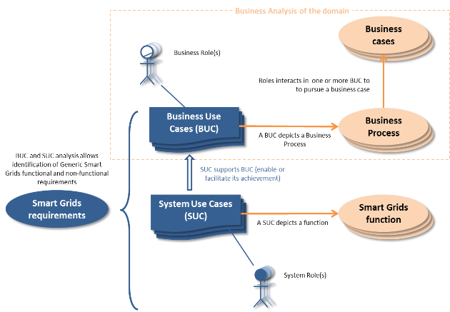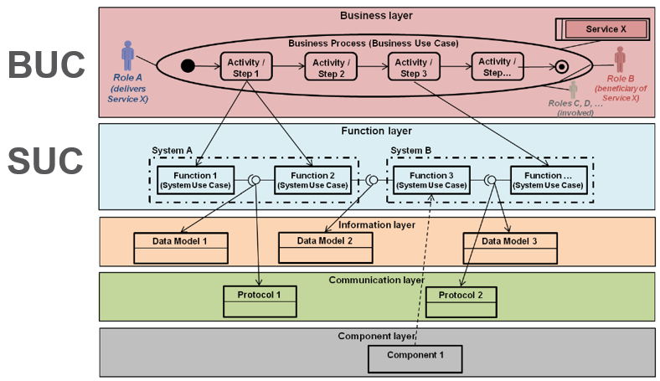

As shown in Figure XXX above, the BUCs (Business Use Cases) would focus on the Business Requirements and following them, SUCs (System Use Cases) can be developed to fit national or regional environments. This will emphasize a good level of interoperability whilst respecting subsidiarity and leaving room for innovation and regional optima.

In the context of this recommendation it also has to be underlined that countries are starting from very different baselines - for example 80 percent in one country pay their energy bill cash up-front, whereas one third of consumers in another country pay for their electricity based on hourly spot price (see D4 - Introduction). Making these ends meet when defining requirements can only be achieved by focussing on the business requirements and leaving room for adaptive national technical solutions.

A good example for such a technology-neutral Business Requirement (just with respect to the aspect discussed here) is “An average switch of supplier must be done within 24 hours.” This leaves room for the national implementation whilst retaining the focus on the vision. Business Use Cases should also use terms and terminology of the Common Role Model and Common Information Model for coherence.

### R05 Use a common approach focusing on the Business Layer leaving the implementation details for the System Level below to the Member State environment

As (provisionally) agreed in the recast Electricity Directive **[ref please],** “Member States shall ensure that electricity undertakings apply these interoperability requirements and procedures, which shall be built on existing national practices”. Our research showed that a good approach would be to focus on

1. the Business Layer and
2. the Information Layer

to define convergence targets (please see SGAM[2] page 30) for a detailed explanation of Figure XX below.

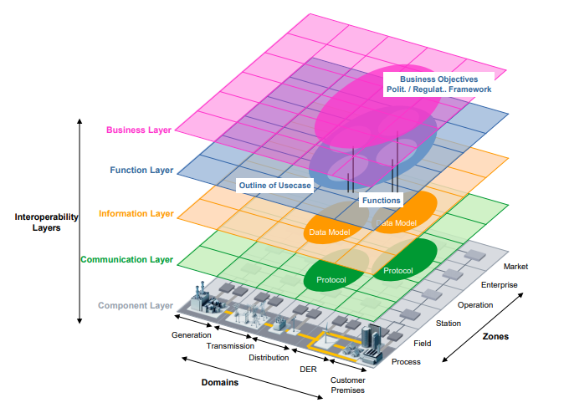

Defining roles, responsibilities, procedures and exchanged information in the Business Layer, would leave space for national Function Layers (e.g. the approach provides the options to countries to go for centralized, decentralized or other data management architectures), whilst emphasizing common understanding through common syntax and semantics defined in the Information Layer. The layers below could again follow national optima and existing practices as required by Article 24. Of course, to reach full interoperability, all layers must be considered. Nevertheless putting a focus on convergence of the Business Layer (roles, responsibilities, procedures and information exchanged), whilst ensuring a common understanding through a common Information Layer will – in our opinion – provide the most value for money whilst respecting Article 24 (first and foremost the intention stated in the beginning of paragraph 2 “In order to promote competition in the retail market and avoid excessive administrative costs for the eligible parties, Member States shall facilitate full interoperability of energy services within the EU”) and – in general – the principle of Subsidiarity and the end of that paragraph stated above.

In addition to the supplier switching example defined in Requirement R05, this would – in the case of roles - mean that a common Roles Model would define e.g. a Meter Data Aggregator or a Meter Data Collector or a Consent Registry Responsible, without prescribing which types of market participants will take over such a role in a national scenario (DSO, TSO, different ESCO, or a Central Data Hub). This could then be part of the – nationally optimized – Function Layer. In the case of procedures the common model should focus on the absolute minimum, whilst the “exchanged information” part should make use of the Common Information Layer do be defined.

### When selecting reference models (SGAM, Common Information Model, Common Role Model, etc.), make sure the bodies developing and maintaining them are representing all relevant Market Participants and stakeholders

For our report we studied a number of already quite good, well-established structures that can be very helpful for a coming Implementation Act. As a reader of this report, please mind that we just could study some examples, not the full picture nor everything available in its entirety, so a more detailed research would make sense. Nevertheless, what can be said with respect to these reference points, is that they are often developed and maintained by different groups, consortia and market participants, but not by all relevant stakeholders. If an Implementation Act prescribes the usage of such structures, it must be guaranteed that the bodies maintaining and furtherly developing these models are legitimized by a *well-defined and transparent stakeholder involvement and review process*.

This is especially important for e.g. a common Role Model (but of course also for the others), as the responsibilities and assignments defined there can have considerable impact on market scenarios and Business Models and are therefore suited to be subject to political interests of diverse stakeholder groups.

Therefore such legitimized and transparent bodies should either be put in place or be a prerequisite for a reference point to be selected by the Implementation Act.

Exemplary gaps identified in the 3 most important models for our work in the group were:

|  |  |
| --- | --- |
| Model | Identified gaps in stakeholder involvement |
| Smart Grids Architecture Model | SGAM has been developed under European Mandate M/490 by CEN, CENELEC and ETSI, probably under more technical considerations. When weaving it in the European legislative framework by e.g. an Implementation Act, development and maintenance procedures need to be adapted to represent TSOs, DSOs, suppliers, regulators, tool vendors, customer representatives and others. |
| Harmonized Electricity Market Role Model | The HEMRM (see [3]) is maintained and developed by ENTSO-E, EFET and ebIX. For a bystander it is very hard to find our out who is taking decisions in that group and how they are undertaken. Apart from that and even more important, there seem to be no representatives from suppliers, regulators, DSOs or customer representatives involved. Although we consider this a very important initiative, it must be ensured all relevant stakeholders are included, when referencing to this model in a future Implementation Act. When adding Gas market support to the model, the inclusion of the respective stakeholders also must be ensured. |
| Common Information Model for Electricity[4] | TC57 working groups are assembled with members of different member states, but not by different market roles. Of course, for example *WG 16 – Deregulated energy market communications* (see [5], same counts for WG 13, both important for CIM) shows liasons with ebIX, ENTSO-E and UCAlug, but important other stake holders like representatives of suppliers, regulators, DSOs, customer interest groups or tool vendors are not – at least not transparently – part of the development process. Also, it might make sense to include Gas stakeholders. |

### The question of whether to use a centralised or decentralised data management model is considered part of the System Layer and Interoperability can be established in and between both scenarios

During the work on our report we studied a lot of analyses and studies discussing whether data management should be done in a more centralized way (e.g. by putting in place Central Data Hubs) or a decentralized approach (e.g. the Energy Data Exchange effort in Austria). Both efforts have strengths and weaknesses and it is very important not to just consider some potential Costs and Benefits, but also the Risks and Opportunities perspective. Preferences will also vary depending on existing national practices and strategies, so our recommendation is not to prescribe or favour an approach. Figure XX below shows that Business Requirements can be met with both approaches at a high degree of Interoperability by utilizing a common Information Layer.

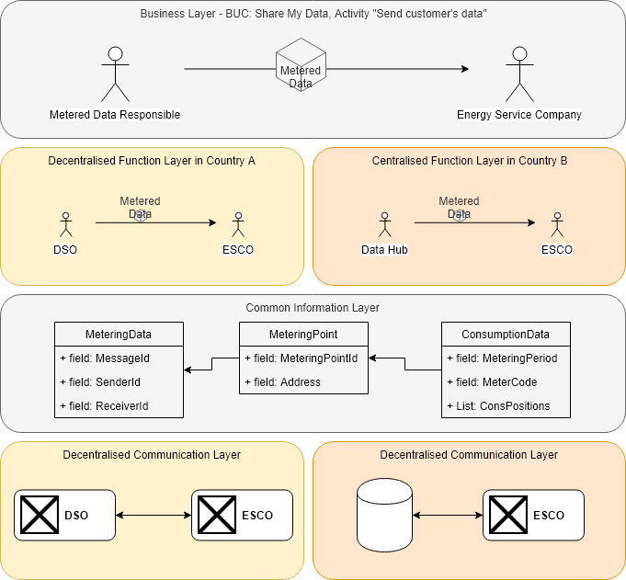

Also regarding these aspects – when elaborating the Implementation Act and respecting Article 24’s paragraph “The Commission … shall determine interoperability requirements and non-discriminatory and transparent procedures for accessing the data, listed under Article 23 (1)” – it must be considered, that we do not know yet the *criticality level of the services that will rely on the data* that will – by the means to be defined in the Implementation Act – be provided by the future Third-Party providers. Services will not be restricted to the Use Case “Supplier makes customer a new offer based on current consumption data”, but might be more critical scenarios.

Bottom line is that if we do not know the criticality level of the services that rely on the data, it is very hard to define the criticality levels of the structures providing them (Data Hubs, TSOs, DSOs, Meter Data Aggregators etc.). What can be done is to require risk mitigation concepts and regular assessments and adaptions.

We strongly recommend that there should not be any preference for the architecture approach in terms of degree of centralization or decentralization and that the decision of how to fulfill the Business Requirements should be left to the Member States. A good degree of interoperability can be ensured with and between the architectures defined in the respective national Function Layer.

## Specific recommendations to existing services

### Billing

#### Subheading 1

### Change of supplier process

#### Subheading 1

## Specific recommendations to emerging services

Interoperability will enable emerging services to be developed and deployed faster among European Member States. Following recommendations will help to reach interoperability for emerging services:

**1. Clearly identify and define all required roles to describe general business use cases and allow all possible implementations at system level.**

Many roles involved in emerging services are described in the Harmonised Electricity Market Role Model[6]. Nevertheless, the management of personal metering data by third parties requires additional protection procedures, particularly in relation with GPDR, and thus, new roles. They are defined as follows:

**The Identity Service Provider**

First of all, it is important to clearly identify and authenticate the user, to prevent identity usurpation or mistakes. This role can be handled by dedicated parties, by the DSO or by a national or regional datahub.

**The Access Rights Manager**

It is then necessary to make sure that the identified user has the rights to access data functionalities related to a given metering point. In many case, this is handled by making sure the user is the customer of the energy contract set in the premises connected with the metering point. In some member states, the contractual customer can also delegate this access to another person (for example a relative living in the same household or a person responsible of their guardianship). In other cases, the access to data functionalities must be granted to another user than the customer of the energy contract: this situation may happen when the energy supply is contracted by a landlord or a company, while tourists, students or elderly people live in the premises.

In all this cases, this link between the user and the metering point used for energy supply/generation should be verified at every access requests, as it may evolve. For example if a family moves out it may not be able to give access to its former house energy data any more.

**The Consent Registry Responsible**

The third role we identified is the management of customer consents. This role consists of storing consents given by consumers to third parties and managing them.

**Metered Data Dispatcher**

The last role is to finally send to metered data to any party that is requesting it (consumer, 3rd party etc.). In many member states, the party responsible of the consent registry is also responsible to send data, but in other member states, this roles are separated.

**2. Describe Business Use Cases and do not forget to consider the proper ending of the use cases**

The descriptions in Business Uses Cases “download my data” and “share my data” should enable a wide range of implementations which encompass all existing and future system configurations.

The proper ending of business use cases are particularly interesting for the energy sector, as these use cases are not fully implemented yet among Member States.

For many applications, customer consent collection has been set in place by data providers in various domains (contact data, house sensor data, mail data, energy data…) to enable controlled data sharing by third parties with respect to GDPR.

In this case the customer is usually free to revoke his consent any time, whatever the consequences for the third parties which provide emerging services. In other words, the propagation of a consent revocation to concerned service providers is not standardised. Because this situation may disturb the contractual relationship with the service provider, it is recommended to implement an information exchange between the consent registry responsible and the service provider so that the last one can be automatically informed of a consent revocation. To sum up, if a consent is revoked, all concerned service providers must reliably be informed to handle future activities and GDPR obligations.

In addition to this, the propagation of a service termination to data providers has not been standardised. This situation leads up to still active data access grants whereas the service is not used anymore: the customer expects the data access to be automatically stopped, but the service provider may potentially keep valid grants to access customer’s data. In an ideal process, the loop would be properly closed and the consent registry responsible would be informed of service termination, in order to de-activate consent and related grants. For this reason it is recommended to implement this information exchange in “share my data” and related “service termination” business use cases. To sum up, if an external service is cancelled, the Consent Registry need to be informed to handle future activities and GDPR obligations. Service termination must propagate consent termination.

The present document describes four relevant Business use cases in appendix relating to “download my data”, “share my data”, “revoke consent” and “terminate service”. Member States may can use these Use Cases to reach interoperability

**3. Use a common information model and carefully address practical issues, on all levels; no matter how small they might seem, they could hamper convergence.**

The fast growth of emerging services will be possible when use data formats will base on a common “reference ontology” which will define univocally a core minimum list of reference terms covering master data (information related to the customer), metering data (information related to the consumption/generation) and consent data (information on the consent for data sharing).

Master data relates to commonly used data/identifiers like customer ID, metering point ID. In this respect, data has been usually harmonized at national level, but the systems are not using the same references so that a European harmonisation would impact utilities IT systems so strongly that it would make no economical sense.

Reference data relates to common standardized representations used as well for master or meter data: units, time, addresses. If units and time representations are now following universal representations and are easily described in an universal format, there is currently no European standard to characterise an address. A generic shared ontology would be welcomed. This ontology should also be able to integrate the separate notions of “metering point” and “delivery point” – which can both differ in locational terms from the customer location.

The present document gives a list of existing standards that cover informations needed for Business Use Cases and can be used to reach interoperability.

# Main report: findings from the EG1 investigation on this topic

# Introduction

Consumers are entitled, in line with the current legislation[7], to receive free of charge their electricity and gas consumption data, and allow access to it to any registered undertaking or a third party of their choice. It is the task of the national regulatory authority to facilitate this through an easily understandable and harmonised framework for the respective data[8]. These provisions are meant to ease consumers' access and understanding of their own consumption, and use of this information to compare offers from energy suppliers or other service providers – including different tariff options. Moreover, the introduction of smart meters, further enriches this data[9] and could be used to create and offer to consumers broader value propositions beyond energy supply.

To facilitate this, and ensure that the required access and data exchanges among eligible parties happen via trusted mechanisms, in a transparent and non-discriminatory manner, standardised national arrangements need to be in place. These should cover a semantic model of the data to be exchanged, the content of data, the format in which data is provided to parties, and the systems and procedures, including communications protocols, used for control, access and the exchange of this data, in line with the EU General Data Protection Regulation[10]. Convergence in such arrangements could facilitate the interoperability of cross-border services and products, serving the interests of the internal energy market and of its consumers.

This Working Group investigated how best to move forward towards such a common framework and converging of national practices in the EU regarding data[11] access and exchange, for both electricity and gas.

The outcome of its work is a set of recommendations, framed following consensus amongst its members, on the scope and coverage of a potentially specific secondary EU legislation that will set up such common arrangements and facilitate the interoperability of cross-border energy services within the EU.

# Approach

The Group agreed, when drawing its terms of reference, that during its first phase of activities, would map national practices in the EU regarding data access and exchange, and then identify commonalities, differences and room for convergence, and consequently how to bridge the gaps focusing on reaching and maintaining interoperability (see roadmap). In doing so, there was an attempt to also inform the investigation with some first thoughts on cost and benefit drivers for such an operation.

The work proceeded in line with this agreement. Furthermore, the Group reached consensus on the detailed strategy that it followed in order to speed up the progress and tackle this complex task. In detail, in this investigation, it was agreed to:

1. Consider both traditional and new and emerging processes[12], for electricity and gas, and launch parallel working streams to address them, to allow ample time to deal with difficulties/obstacles in collecting and analysing data and to accordingly refine the convergence strategy and investigation based on best practices and lessons learnt (see Nordics' experience)
   * Traditional processes: starting first with *Change of Supplier*, and then *Billing*;
   * New & Emerging services: (i) *"Download my consumption/generation data"; (ii) "Giving access to my (consumption/generation) data to third parties (historical data)"; (iii) "Giving access to my (consumption/generation) data to third parties (near-real time data)”.*
2. For each one of these processes, identify:
   * roles and procedures (e.g. role model).
   * type of information exchanged (semantic model, identifiers, etc.).
   * data formats used (XML, CSV, …)
   * data exchange technology used (HTTP, FTP, Platforms, security, data privacy, performance, validation, authentication, non-repudiation, …)
3. Draft a common, basic, template to be used for the description of processes and ease benchmarking
   * run it at first instance for few countries (mainly those for which members had better access to information) to get indications on common features and differences, and later confirm these based on a wider sampling;
   * in the light of the above proceed with the investigation on the potential for convergence of national arrangements.

At the same time, the Group agreed to comment, and give feedback to an external study[13] launched by the Commission on national practices for electricity and gas data access and exchange. The findings of this study, regarding particularly elements on data management arrangements and role models for these processes, provided also input to the Group's work.

# Interoperability of energy services and data access and exchange

## General thoughts on interoperability

## Approach to interoperability

## Reaching & maintaining interoperability in specific processes/ Use Cases

## Key findings

### Cost/benefit drivers

### Interoperability over time - Governance

## Recommendations

# National practices regarding data access and exchange & room for convergence



## Findings regarding the Billing Process

### Introduction & purpose

### Different existing models

#### Subheading 1

#### Subheading 1

#### Subheading 1

### Conclusions on billing process

## Findings regarding the Change of Supplier Process

### Introduction & purpose

### Existing (data and role) models and procedures

#### Subheading 1

#### Subheading 1

#### Subheading 1

### Conclusions on change of supplier process

## Findings regarding Processes supporting New and Emerging Services

### Introduction & purpose

The evolution of electricity and gas systems, enabled by innovation and digitalization, in a global move toward energy transition, is large and fast. The intensity of this transformation is especially visible at systems consumption and generation endpoints: new applications related to Smart Homes, Smart Buildings, EV charging, smart offers from suppliers, aggregators, etc. Besides, the environment is becoming more complex with new applicable obligations (e.g. GDPR), new business models (e.g. blockchains based, cross-sector applications like insurance). On the top of this, new societal and organisational concepts are developing: Local Energy Communities, MyData movement[14], etc.).

To amplify the development at an EU-wide perimeter of those new services, which rely highly on data sharing, interoperability and convergence on data formats and procedures are considered as key enablers.

The target of this subsection is to address this stake by facilitating the development of new “energy data based services” across Member States and finding the right level of minimum requirements in order also to let room for innovation regarding a scope of emerging services still at an early stage of development.

An enquiry was made whether use cases should be described and cover all emerging services for the energy sector, including PVs, storage, flexibility, etc.  By definition emerging services are not already known and defined, hence the subgroup concentrated on common parts of the procedures that would be needed to enable customers to share their data.

Taking into account the EG1 “My Energy Data” report (2016), we started to focus on the two functional use cases that have been described from a high level perspective as follows:

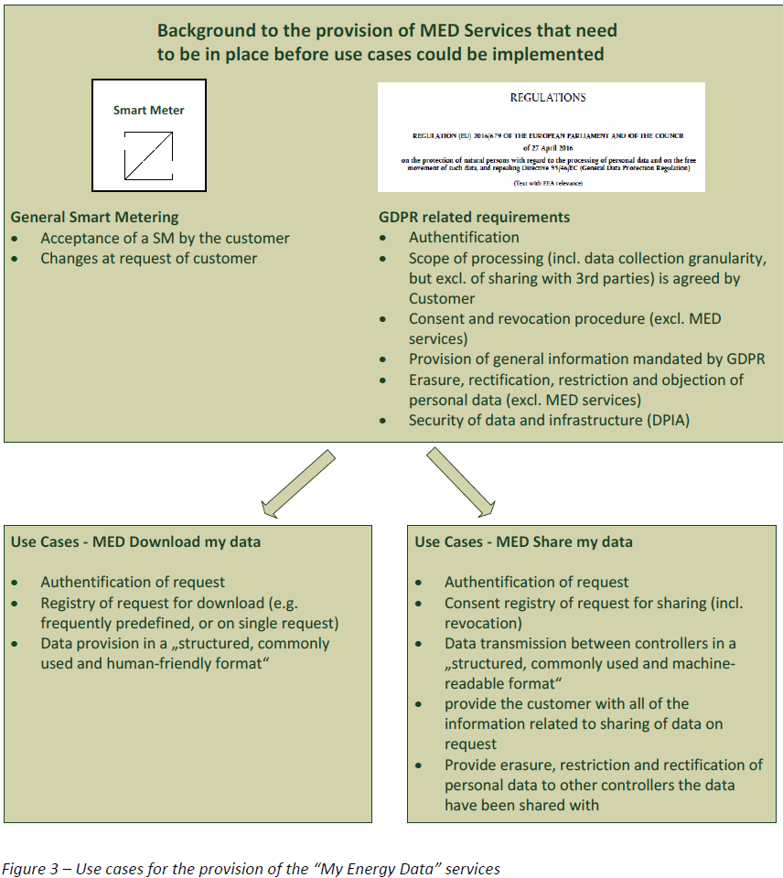

While considering the new “energy data based services”, the importance of the GDPR and more precisely the consent of the end-consumer regarding the transfer of data to other parties should be integrated, in particularly the consent management.

In terms of methodology, the present study focused on procedures, data formats and roles that are used in a selection of real use cases. After comparing them and having identified the commonalities and the differences, generic business use cases could be specified and their applicability checked through a survey among all MS. From those results were drawn conclusions and recommendations.

Restriction: the scope of the analysis and the recommendations does not cover the direct real-time data access from the meter, as this issue was already explored by EG1 [Standards and interoperability, 2015].

### Emerging and potential (data and role) models

#### Illustrative examples of Emerging services

This paragraph describes what these new services can be and the diversity of third parties interested in energy data based services.

In order for end consumers to have access to a full range of services adapted to their diverse backgrounds and expectations, it is important for all parties to have access to energy data, with informed consent from the owner of this data (the consumer).

Various third-parties are already expressing great interest in itemized consumption data, and are seeking to position themselves in this market by developing or improving services targeting different categories of end consumers. These groups can include (which is a non-exhaustive but just an illustration list):

* Traditional stakeholders and energy-management experts, for example, who believe itemized consumption data will be useful for improving existing tools and support measures.
* Stakeholders in the digital realm, who seek to position themselves in this new market and incorporate consumption tracking in other services : many app developers and start-ups are already interested in the energy consumption data of their current or future users
* In the context of smart cities, new platforms may be developed to offer services to citizens, including some energy consumption monitoring tools

In addition, numerous stakeholders have a key role to play in adding value to energy consumption data by processing them in specific manner and, in particular, intersecting them with other data. There are in fact many ways to use these data, and enriching this type of data should make it possible to develop varied and reliable services to meet the divergent expectations of the various categories of end consumers.

#### Existing models

To illustrate the diversity of existing models among European Countries, the workgroup established first a simplified view based on the analysis on EG1 My Energy Data (MED) and Tractebel reports[15], completed by inputs brought by EG1 members e.g. Alliander (NL), EDA (AT), Enedis (FR), GRDF (FR).

The variety of existing “national” or “regional” electrical and gas standards, as well procedures as data models, were used to list globally what could be found as common and different from one to another. Accordingly with the interoperability approach, the work was concentrated on Business Use Cases (procedures) and on semantic and syntactical interoperability (information models and data syntaxes).

Concerning procedures for emerging services, all studied implementations showed differences at a system level, whether centralized or decentralized, but all could fit in a generic business use case description with only one option to set up, depending on whether the Consent Registry Responsible or the Metered Data Responsible executes the data requests.

Concerning data models, data format and semantic comparison showed the coexistence of several data formats: ebIX, EDA, EDIFACT, IEC Common Information Model (CIM), DLMS/COSEM[16]. The workgroup included also the recently defined SAREF4energy ontology.

These specifications cover electricity and gas metering data, or can be easily adapted to cover both.

#### Roles and responsibilities

This chapter explains the roles that are needed to describe the use cases: beyond the already existing pre-defined roles that are involved in already described use cases[17], **new roles** had to be considered to describe consent collection and management, consistently with GDPR.

The definitions of the “front” roles like customer, 1st, 2nd and 3rd Party have been first written down by the working group; their relationships are illustrated in the following figure (where colours are used to differentiate between parties).

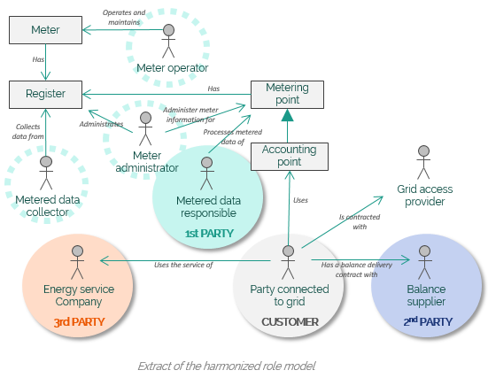

The description of these different roles and responsibilities attributions, which are encountered among Member States, were based on existing models such as the Harmonized electricity role model[18].

* The customer will be then referred to as the “Party connected to the grid”,
* The 1st party as the “Metered Data Dispatcher”,
* The 2nd party as the “Balance Supplier”,
* and the 3rd party as “Energy Service Company”, which provides the energy data based service

In order to take into account the new requirements to comply with the GDPR, the two following new roles were defined, consistently with the previous EG1 work[19], and added:

* The “Consent Registry Responsible”, which collects, operates and deletes customer consents
* The “Identity Service Provider”, which offers an authentication service to identify the customer
* The “Access Rights Manager”, which grants an user the rights to access data functionalities related to a given metering point
* The “Metered Data Dispatcher”, which sends metered data to the authorized third party and the consumer

The complete set of roles that are needed for the Business Uses Cases definition is then:

|  |  |
| --- | --- |
| Party Connected to the Grid (*) | A party, also described as the “customer”, that contracts for the right to consume or produce electricity and gas at an Accounting Point |
| Balance Supplier (*) | A party that markets the difference between actual metered energy consumption and the energy bought with firm energy contracts by the Party Connected to the Grid. In addition, the Balance Supplier markets any difference with the firm energy contract (of the Party Connected to the Grid) and the metered production.  Is also referred to as “second party” in the document. There is only one Balance Supplier for each Accounting Point. |
| Energy Service Company (*) | A party offering energy-related services to the Party Connected to Grid, but not directly active in the energy value chain or the physical infrastructure itself. The Energy Service Company (ESCO) may provide insight services as well as energy management services. Additional information: is also referred to as “third party” in the document. |
| Consent Registry Responsible | A party responsible for the management of the customer consent registry. He receives consents and revocation notifications from authorized parties, stores and operates the consent registry, revokes and delete consents, and notifies the execution of requests to concerned parties. |
| Identity Service Provider | A party offering an authentication service for the other involved parties, to identify the customer. |
| Right Access Manager | A party responsible for establishing and checking the link between a customer and a given metering point for the other involved parties. It guarantees that the customer is authorised to use “data access”, “data sharing” and “consent management” functionalities related to a metering point. |
| Metered Data Dispatcher | A party responsible to send metered data to the customer and to authorized parties. |

(*) Roles already defined in the Harmonized Electricity Market Role Model.

Ensuring interoperability and guaranteeing that all procedure descriptions are well understood before implementation require this set of roles to be defined in detail and consistently with the existing ones. They may for example be integrated as an extension of the Harmonized Electricity Market Role Model.

#### Procedures

Four generic Business Use Cases could be defined after having established several examples of customer journeys that may be encountered in the already existing implementations of the use cases “download my data” and “share my data”. A specific procedure for “consent revocation” was needed and defined as a specific use case, as well as the “service termination” which requires consent revocation.

Overviews of the use cases follow. They are fully described in annex.

* Download my data

The Business Use Case describes how the Consumer (“Party Connected to the Grid”) can request data and how the Metering Data Responsible sends metered data (consumption and/or production) back to the Consumer in a formalised and standardised way. This allows the Consumer to make use of (commercial) tools and services to present and analyse the data.

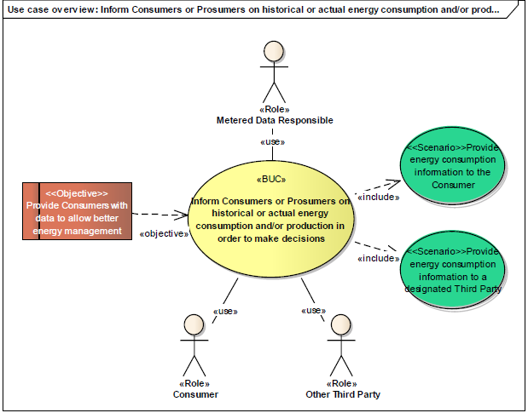

* Share my data

This Business Use Case describes how an agreement between the customer and a second/third party can be found in order for the customer to benefit new services after giving access to his/her personal energy data to the second/third party.

Share my data - overview

* Revoke consent

This Business Use Case describes the journey a customer should take to revoke his/her consent given to a second/third party to access his/her personal energy data.

Scenario1 - overview

* Terminate service

In addition to “Revoke consent”, this Business Use Case considers the journey of a customer who does not want to benefit from the service any more. In this case, it is assumed that the customer implicitly expects the data collection and the data access to stop.

Scenario1 - overview

In this phase of business use case description, following issues were identified:

* The link between customer and metering point(s) must be precise and up to date for all described business use cases to be efficient, in particularly the information of customers move out should be propagated to concerned parties without delay to avoid undue data access or deny.
* The link between a Customer and a Metering point is key for the reliable functioning of data access and consent management. In some cases the link is not obvious, e.g. to which person(s) from a family or friends living in the same house should the link be done? Should the link be done with the landlord and the occupants or both? An additional insight is needed to clarify these questions.
* When a customer revokes a consent for data sharing, or terminates a service basing on her/his energy data access, then both consent registry responsible and the 2nd/3rd Party which provides the service should inform themselves respectively of the service/data sharing ending. If they don’t, they are likely to face unwanted situations such as, for the 2nd /3rd Party, having technical access to a person who is no longer client of its services, or trying to deliver a service while the customer has already cut access to his/her energy data.

#### Data models and data exchange

**What could be the minimum requirements to make targeted data interoperable**, to enable a cost-effective way to link with and convert to all existing models and pave the way to reaching and maintaining interoperability?

The existing material from EG1 report “My Energy Data” and Tractebel report on energy data has been used to identify of a core data model that could be used as semantic pivotal meta-model for interoperability. More data standards are existing that cover the data for the concerning Use Cases. We have identified the CIM data elements here as an example

Two categories have been identified to download and share data: Master Data and Metering Data.

Master Data:

* Consumer identifier

CIM equivalent: MyEnergyData_MarketDocument/MarketParticipant/mRID

* Metering point identifier

CIM equivalent: MyEnergyData_MarketDocument/TimeSeries/MarketEvaluationPoint/mRID

* Optional: customer information, location information (customer, metering point)

CIM equivalent: MyEnergyData_MarketDocument/TimeSeries/MarketEvaluationPoint/UsagePointLocation/geoInfoReference

Meter Data:

* Metering point identifier

CIM equivalent: MyEnergyData_MarketDocument/TimeSeries/MarketEvaluationPoint/mRID

* Type of energy (electricity, gas)

CIM equivalent: MyEnergyData_MarketDocument/TimeSeries/product

* Metering period

CIM equivalent: MyEnergyData_MarketDocument/Time_Period/timeInterval

* Metering interval

CIM equivalent: MyEnergyData_MarketDocument/TimeSeries/Series_Period/timeInterval

* Unit of measure

CIM equivalent: MyEnergyData_MarketDocument/TimeSeries/Measure_Unit/name

* Energy quantity (time series)

CIM equivalent: MyEnergyData_MarketDocument/TimeSeries/Series_Period/Point/Quantity/quantity

* Optional: quality indicators

CIM equivalent: MyEnergyData_MarketDocument/TimeSeries/Series_Period/Point/Quantity/quality

In the business use case “share my data”, the consent is required by the Metered Data Responsible for GDPR compliance, so that it can give access to the specified energy data for a 2nd/3rd Party.

The 2nd/3rd Party which offers a service based on energy data is itself a data processor, as it uses customer energy data for service delivery. It needs therefore to also collect itself an explicit consent from the customer for its specific purpose(s).

For the Metered Data Responsible, the minimum data required for a “data access” consent is following:

* Customer identifier
* Metering point identifier
* 2nd/3rd Party to which consent is given
* List of data to which access has been consented - related to meter data and master data
* Validity (starting, ending)
* Optional: storage and utilization conditions (time limitation)

In this phase of minimum core data model definition, following issues were identified:

* Locational information: a generic shared ontology would be welcomed. It should clarify the distinction between metering point, delivering point and customer location, as these terms may lead to a confusion when it comes to locational information. Besides, there are usually consistent national representations to design a postal address, but no European standard is available to characterize an address in the same way.
* Time series: there are several syntactic solutions to describe time series (timestamps, interval blocks, …) and many other meta data to characterize it. Which metadata may be considered as minimum requirements (e.g.: timestamp, quality, …)
* Metering data: the workgroup concentrated on consumption/generation data. May other physical values also be measured and shared: power peak, reactive power, voltage, … ?

To conclude on data models, the adoption of one single reference ontology as an interoperable data model is very welcomed, so that each data format may be translated to the reference model.

### Conclusions on processes supporting new and emerging services

The recommendations that are applicable for Member States are following:

**1. Clearly identify and define all required roles to describe general business use cases and allow all possible implementations at system level.**

There is an existing Role Model on European level available to start new business use cases description: the Harmonized Electricity Market Role Model (aforementioned in §4.3).

In the context of emerging services, this existing role model needs to be adapted in order to fit with gas, and new roles will be needed next to existing ones:

* A party responsible for customer identification and authentication
* A party responsible for guaranteeing the association between a Customer and a Metering point
* A party responsible for the Consent Registry, which manages consents (storage, revocation)
* A party responsible for sending metered data to authorized third party

It is important to clearly identify the Customer (“Party connected to the Grid”) and to establish an unambiguous link between he/she and the metering point used for energy supply/generation. The identity and the link should be verified during the contracting phase and checked again when receiving data access requests, as they will prevent undue data accesses.

It should also be always clear who has access to what data and under which conditions. For instance, there is not always a 1:1 relation between metering point, land lord and actual customer, the link between the customer and the metering point ID must be defined with caution.

**2. Describe Business Use Cases and do not forget to consider the proper completion of the use cases**

Business Use Cases have been described and are available as basic models on European level in the appendix.

The descriptions in Business Uses Cases “download my data” and “share my data” should enable a wide range of implementations which encompass all existing and future system configurations.

For many applications, customer consent collection has been set in place by data providers in various domains (contact data, house sensor data, mail data, energy data…) to enable controlled data sharing by third parties with respect to GDPR.

The proper completion and implementation of business use cases are particularly interesting for the energy sector, as these use cases are not fully implemented yet among Member States:  
- If a consent is revoked, all concerned service providers must reliably be informed to handle future activities and GDPR obligations;  
- If an external service is cancelled, the Consent Registry need to be informed to handle future activities and GDPR obligations. Service termination must propagate consent termination.

**3. Use a Common Information Model and carefully address practical issues, on all levels; no matter how small they might seem, they could hamper convergence.**

There is an existing international Common Information Model available: the CIM defined by the IEC[20]. for electricity systems. It can be reused and easily adapted to fit for purpose, like the inclusion of gas related data.

The fast growth of emerging services will be possible when data formats will be based on a common “reference ontology” which will define univocally a core minimum list of reference terms covering master data (information related to the customer), metering data (information related to the consumption/generation) and consent data (information on the consent for data sharing).

Reference data relates to common standardized representations: units, time, addresses. There is currently no European standard to characterise an address: a generic shared ontology would be welcomed. This ontology should also be able to integrate the separate notions of “metering point” and “delivery point” – which can both differ in locational terms from the customer location.

There are international standards for the data models and information exchange: EDIFACT, ebIX, CIM, DLMS/COSEM. They can be used to define data formats applicable for information exchanges.

# Annexes

# Smart Grids Task Force EG1 – modus operandi

## Terms of Reference & Roadmap

The Group's Terms of Reference (ToR), defining amongst others the scope and structure of its work, were timely drafted, submitted (the 30/06/2017), and finally validated by the Steering Committee. This final, approved version has been made available online on the dedicated web site of the Smart Grids Task Force[21]. Moreover, the Group developed a roadmap, as one of its first outputs, with key milestones and deliverables foreseen throughout its mandate.

*Figure 1 – Roadmap for this Working Group*

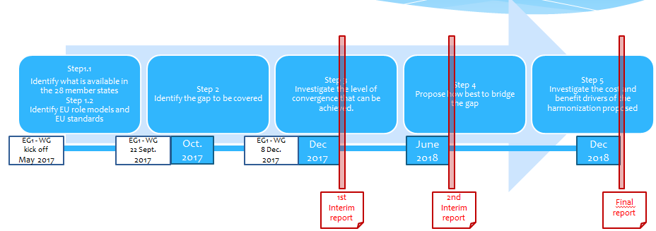

After the initial slow start, and following on the momentum built at the end of last year, the Group members were extensively more involved in the respective tasks mainly through the ad-hoc subgroups that was formed to progress with the work. These informal structures gave the opportunity to also pull further expertise from the associations represented in the Group, and further advance with the work. Instrumental to the successful completion of this exercise have been few key contributors, the subgroup leaders, and the coordinating efforts of the Editorial Team.

## Group membership

The external experts– main representatives and their alternates – who were members of this Group and their affiliation, can be seen below. Changes in the original composition notified to the Steering Committee with the ToR are also indicated. The listed members in this Group have been nominated by the organisations participating in the Smart Grids Task Force Steering Committee, and undertook their work by means of their own resources.

## Working methods

The Group, as already agreed in its ToR, proceeded with the work, as well as with its specific deliverables based on consensus among all actors involved.

In order to progress with the work, as mentioned earlier, the Group decided to take a practical step and form four ad-hoc working teams (subgroups) that were asked to investigate in depth the relevant issues in three processes – *change of supplier*, *billing*, support to new and *emerging services* – and the horizontal issue of *interoperability*. It was agreed that the subgroups' findings would need to be approved by the whole assembly of EG1 to be considered as valid outcomes.

The Group reported on its overall progress to the Smart Grids Task Force Steering Committee, through two interim reports, in addition to this final report.

The work and the drafting of the respective deliverables with inputs from Group members was coordinated, since its establishment, by an Editorial Team(ET) of five who were assisted by a few key contributors and the European Commission. The Editorial Team was set up at the kick off meeting, in line with the agreed ToR, and consisted of members from the following organisations: CEER, Eurelectric, ENTSO-E, ESMIG and ebIX (see list of experts below).

## Meetings

Since the establishment of the Group, and its kick off meeting the 24/05/2017, six more physical meetings with the whole assembly were held in Brussels, chaired, and organised by the European Commission, at its premises. These were two meetings in 2017, the 22/09/2017 and the 07/12/2017, and four more held in 2018, the 19/03/2018, 18/06/2018, 02/10/2018 and 10/12/2018. At the same time, the ET and the subgroup teams were engaged in regular, mostly weekly, teleconferences to progress with the work and coordinate actions.

During the first reporting period, members of the ET participated, on Commission's request, in the progress meeting of a related external study on data that the Commission has previously launched and findings of which could potentially be of interest to this Group.

## Membership

|  |  |  |  |
| --- | --- | --- | --- |
| **Working Group"Electricity and Gas Data Format & Procedures", chair: European Commission** | | | |
| **EC** | **DG ENER** | Manuel Sánchez Jiménez  Constantina Filiou  Niels Ladefoged  Mario Dionisio  Michela Marasco |  |
|  | **DG CNECT** | Patricia Arsene |  |
|  | **DG GROW** | Zsuzsanna Dakai |  |
|  | **DG JRC** | Ioulia Papaioannou  Nikoleta Andreadou  Igor Nai Fovino |  |
|  | **DG JUST** | Georgios Kiriazis |  |
|  | **DG RTD** | Patrick van Hove |  |
|  | **INEA** | Mariana Stantcheva |  |
|  | **Association** | **Expert** | **Alternate** |
| **Nomination of one expert and one alternate**   1. No alternate 2. Multiple functional player 3. Covering also the role of supplier 4. 2 experts and 2 alternates 5. EC ask BEUC case by case, according with the issue to discuss   (*) Changes in composition since last notification to the Steering Committee | **CEER** | Christelle Heng – FR NRA (*) | Deniz Erdem – DE NRA |
| **CEDEC(1) (2)** | Christian Richter – vku (DE) | - |
| **EDSO (1)** | Jean-François Montagne -Enedis | - |
| **Eurelectric (1) (3)** | DSO issues: Paul de Wit – Alliander  Supply issues: Kajsa Lilius – Öresundskraft | - |
| **GEODE (1)** | Franz Fischer – Energie AG | - |
| **ENTSO-E (4)** | Olivier Aine – ENTSO-E  Fabio Oliveira – ENTSO-E(*) | Norela Constantinescu –ENTSO-E  Kalle Kukk – ELERING (*) |
| **Orgalime/T&D** | Jean-Luc Roy – GE (*) | Sigrid Linher – ORGALIME |
| **ESMIG** | Miguel Gaspar – SAP | Willem Strabbing –ESMIG |
| **ANEC/BEUC (5)** | Neil Avery – ANEC | Ieva Galkytè – ANEC (*) |
| **SmartEn [(*) former SEDC]** | Chris King – Siemens Digital Grid | Layla Sawyer – SmartEn (*) |
| **ENTSO-G (4)** | Marin Zwetkow – ENTSOG  Jef de Keyser – ENTSOG |  |
| **Eurogas (1)** | Julien Quainon – DSO GRDF |  |
| **MARCOGAZ** | Jos Dehaeseleer – Marcogaz | Henk Koorenhof – Gasunie |
| **ebIX** | Kees Sparreboom – TenneT | Vlatka Cordes - Westnetz |
| **CEN/CENELEC** (*) | Eric Lambert (*) | John Cowburn (*) |

|  |  |  |  |  |  |  |  |  |  |  |  |  |  |  |  |  |  |  |  |  |
| --- | --- | --- | --- | --- | --- | --- | --- | --- | --- | --- | --- | --- | --- | --- | --- | --- | --- | --- | --- | --- |
| |  |  | | --- | --- | | **Association** | **Editorial Team (ET) composition** | | **CEER** | Christelle Heng | | **Eurelectric** | Paul de Wit | | **ENTSO-E** | Olivier Aine | | **ESMIG** | Miguel Gaspar | | **ebIX** | Kees Sparreboom | |  | **Key contributors assisting the ET** | | **EDSO** | Jeff Montagne | | **GEODE** | Franz Fischer | | **CEN-CENELEC** | Eric Lambert | |

|  |  |  |  |  |  |  |  |  |  |  |
| --- | --- | --- | --- | --- | --- | --- | --- | --- | --- | --- |
| |  |  | | --- | --- | | **Ad-hoc Subgroup** | **Subgroup leader (Association)** | | **Change of Supplier** | Kees Sparreboom (ebIX) | | **Billing** | Paul de Wit (Eurelectric) | | **New & Emerging Services** | Jeff Montagne (EDSO) | | **Interoperability** | since 05/2018 Georg Hartner (GEODE);  earlier Olivier Aine (ENTSO-E) | |

# Deliverables and supporting material regarding interoperability

## Heading 2

## Heading 2

* 1. Deliverable 3 - Cost-benefit considerations

## Deliverable 4 - Governance & interoperability over time

# Deliverables and supporting material regarding the billing process

## Heading 2

## Heading 2

## Heading 2

# Deliverables and supporting material regarding the change of supplier process

## Heading 2

## Heading 2

## Heading 2

# Deliverables and supporting material regarding emerging services

## Heading 2

## Heading 2

## Heading 2

1. Clean Energy Package: <https://ec.europa.eu/energy/en/news/commission-proposes-new-rules-consumer-centred-clean-energy-transition> ; most relevant to this work is the recast Electricity Directive COM/2016/0864/final/2 and its Articles 23 and 24.
2. Smart Grids Architecture Model: <https://ec.europa.eu/energy/sites/ener/files/documents/xpert_group1_reference_architecture.pdf>
3. Harmonised Electricity Role Model: <https://www.entsoe.eu/digital/cim/role-models/>
4. Common Information Model: <https://www.entsoe.eu/digital/cim/>
5. IEC TC 57 Power systems management and associated information exchange, WG 16 Deregulated energy market communications: <https://www.iec.ch/dyn/www/f?p=103:14:0::::FSP_ORG_ID:2388>
6. The harmonized electricity market role model v2017-01   
   https://docstore.entsoe.eu/Documents/EDI/Library/HRM/Harmonised_Role_Model_2017-01.pdf
7. Directive 2009/72/EC and Directive 2009/73/EC; point Annex I.1(h)
8. Article 37(p) of the Electricity Directive, Article 41(q) of the Gas Directive.
9. Cf. also Articles 9(2) and 10(2) of Directive 2012/27/EU (the Energy Efficiency Directive)
10. General Data Protection Regulation (EU) 2016/679
11. The data concerned is that referenced in the respective legislation:

    (i) in the Third Energy Package (Annex I.1(h)): "(ensure that customers) have at their disposal their **consumption data**, and shall be able to, by explicit agreement and free of charge, give any registered supply undertaking access to its **metering data**. …; "

    (ii) in the recast Electricity Directive COM(2016) 864 final/2 (Article 23(1)): "…For the purpose of this

    Directive, data shall include **metering** and **consumption data** as well as **data required for consumer switching**... "
12. For the purpose of this document processes are understood to be implemented via procedures.
13. ASSET HORIZON 2020 project – Study no.4: “Format and procedures for electricity (and gas) data access and exchange in Member States”, March 2018; <https://asset.te-ded.com/home/advanced-system-studies/cluster-7/format-and-procedures-for-electricity-and-gas-data-access-and-exchange-in-member-states/>
14. See the Declaration of MyData Principles: <https://mydata.org/declaration/>
15. Tractebel report 2018 on Data format and procedures; the study constitutes one of the deliverables of the ASSET HORIZON 2020 project; [www.asset-ec.eu](http://www.asset-ec.eu)
16. It has to be pointed-out that IEC CIM and DLMS-COSEM are recognized as key Smart grid standards by IEC TR 63097 “Smart Grid Standardization Roadmap” , and that they have been harmonized through IEC 62056-6-9 “Mapping between the Common Information Model message profiles (IEC 61968-9) and DLMS/COSEM (IEC 62056) data models and protocols”.
17. see EG1 My Energy Data report for role description, based on GDPR roles & SGTF / Harmonised role models.
18. The harmonized electricity market role model, v2017-01
19. My Energy Data Role Model from ESGTF – EG1 – My Energy Data interim report nov 2016
20. https://en.wikipedia.org/wiki/Common_Information_Model_(electricity)
21. Terms of Reference of the Working Group on Data Format and Procedures - https://ec.europa.eu/energy/sites/ener/files/documents/tor_eg1_wg_on_data_format_procedures.pdf